## Todo: to record all of the following “transcripts”

# Part 1) Indirect communication

## 1st row Communication and gender

## Stop) Lexical resource:

* (classroom, room ）闷热的；不通气的 [ hot and stuffy ] If **it is stuffy in a place**, it is unpleasantly warm and there is not enough fresh air.   
  e.g. **It’s so hot and stuffy in this room** even though/if/although the **air purifier** does work. I cannot even breathe. e.g. **It was hot and stuffy in the classroom** **even though** two of the windows at the back had been opened教室里还是很**闷热**  e.g. I **felt down** because I was working **in a stuffy shop**  我们的**情绪很低落**，因为我正在一家闷热的商店里工作
* **[ a tag question]** v.s. **r[h]etoric question 反问句**

**Tip**: Using a tag question is a good way to bring the other person into the conversation.

|  |  |
| --- | --- |
| A tag question | * R(h)etoric question反问句 |
| You didn’t bring my umbrella, did you? | Who don’t want that **magic wand**? **魔术棒** |
| You don’t wanna go shopping with him, **do you?** | Why don’t you say ‘No’? |
| You love summer, don’t you? |  |

* **礼仪/姿学校, 美姿学校 (教少女仪态及服饰的学校) a charm school**e.g. She went to **a charm school** to learn how to act properly, esp. the **business etiquette(商务礼仪);** and how to dress yourself elegantly 她去 礼仪学校 学习如何进退得体, esp. 商务礼仪, 以及学习如何优雅的穿衣. E.g. I'm **enrolling you in** **charm school**, to learn how to act properly and how to dress yourself elegantly. 我要帮你报名**礼仪学校**
* 情绪很低落 Sb. feel down    
  e.g. I **felt down** because I was working **in a stuffy shop**  我的**情绪很低落**，在一家**闷热的商店**里工作
* **spade**:  铁锹，铲子; (扑克牌中的) 黑桃 V.S. **shovel** (用来铲土，煤，雪的)铲子

1. A spade is a tool used for digging, with a flat metal blade and a long handle. 铁锹，铲子
2. Sb. **call a spade a spade**. **Please call a spade a spade. 有什么话就说吧！ 直言不讳；实话实说**
3. Spades is one of the four suits in a deck of playing cards/poker. Each card in the suit is marked with one or more black heart symbols: ♠. (扑克牌中的) 黑桃 **[ the ace of spades 黑桃A ]**

* **shovel** /ˈʃʌvəl/

1．n) A shovel is a tool with a long handle that is used for **lifting and moving** earth, soil, coal, or snow. (用来铲土，煤，雪的)铲子 **[ a coal shovel 一把煤铲 ]**

2.V-T If you **[ shovel earth, soil, coal, or snow ]** , you lift and move it with a shovel. 用铲挖; 铲起(土，煤，雪) e.g. After the horrific **blizzard暴风雪**, he has to get out and **shovel snow**. 出去**铲雪**。

3.V-T If you shovel something somewhere, you push a lot of it quickly into that place. 把…大量送入 e.g He was **shovelling food into his mouth** 把食物大口大口地塞进嘴里 **= devour food= snarf down food 狼吞虎咽**

* altercation: 口角，争论 ( alter = change V.S. **altercate with sb.** => altercation )  
  **e.g.** Europe's **budget airline廉价航空** EasyJet flew into a storm Sunday after it emerged a member of **the ground staff地勤** at Nice /nis/ airport in France **had punched out** one of its passengers in the face while he was holding a baby. The flight was delayed for a **grueling 受煎熬的**11 hours. "It was awful the whole thing. **It’s inconceivable that 难以置信/想像** the ground staff can behave like that," said fellow passenger Arabella, who photographed the **altercation**口角
* punch /pʌntʃ/

1.V-T If you **punch sb/sth** or **punch out sb/sth**, you hit them hard **with your fist**. 用拳猛击 [ punch your face; punch your ass ]   
e.g. The boxer **punched his rival’s face**. e.g. E.g. He was finally **outraged**愤慨的，气愤的 and **punched out** that disgusting guy.   
E.g Europe's **budget airline廉价航空** EasyJet flew into a storm Sunday after it emerged a member of **the ground staff地勤** at Nice airport in France **had punched out** one of its passengers in the face while he was holding a baby. The flight was delayed for a **grueling 受煎熬的**11 hours. EasyJet says the airport employee does not work for the airline.

2.N  Punch is also a noun. (猛的)一拳 e.g. He was hurting Johansson with body **punches** in **the fourth round**. 他在 **第4个回合**猛击约翰逊的身体。 E.g. He had a mark from the **punch** on his face.

4.V-T If you punch something such as the buttons on a keyboard, you touch them in order to store information on a machine such as a computer or to give the machine a command to do something. 按 (键或钮) e.g. Mrs. Baylor strode to the lift and **punched the button**. 按了一下按钮。

5.V-T If you **punch a hole in something (such as wall),** you make holes in it by pushing or pressing it with something sharp. **在…上打孔, 在xxx上戳了个孔** e.g. I took a **ballpoint pen** 圆珠笔and **punched a hole in the carton**. 我拿了一支圆珠笔 **在<纸板箱>上戳了个孔**。

6.N) A punch is a stationery that you use for making holes in something. 打孔器 e.g. Make two holes with **a hole punch.** 用打孔器打两个孔。

7.N) If you say that **something has punch**, you mean that it has force or effectiveness. 力量; 效力 e.g. I’m a little **inhibited拘谨/约束的/放不开** in public, and my nervousness made me deliver the vital points of my address/presentation **without sufficient/enough punch**. 讲到演说关键地方时 **不够有力**。

8.N  Punch is a drink made from wine, spirits, or fruit juice, mixed with things such as sugar and spices. 潘趣酒 ..a bowl of punch.…一碗潘趣酒。

=>

|  |
| --- |
| punch lines = quip: The punchline of a joke or funny story is its **last sentence or phrase,** which makes it funny.  笑话或警句令人发笑的最后一行 |
| A **punch list** is generally a list of tasks or "to-do" items that must be done in a limited time. In the U. |

* Camp, campfire 营火；营火会，篝火 (a small outdoor fire for warmth or cooking (as at a camp)

e.g. I love camping, esp with campfire.

* dreaded /ˈdrɛdɪd/

1.ADJ Dreaded means terrible and greatly feared. 可怕的; 令人畏惧的 e.g. No one knew how to treat this **dreaded disease**. 治疗这种 **可怕的疾病**。

2.ADJ You can use the dreaded to describe **something** that you, or a particular group of people, find annoying, irritating, inconvenient, or undesirable. 讨厌的(事情); 令人不快的(事情） E.g. YangMi, one of the most **sought-after(吃香的)** actors in China, said she has been **getting fe[d u]p with**/sick of/tired of/weary of **the dreaded paparazzi’s eavesdropping令人讨厌的狗仔的窃听行为**.

# Stop here: review this handout

* lap /læp/  **(人坐着时的)** 大腿部 V.S thigh /θaɪ/ 大腿

1.N)  If you have something **on your lap** when you **are sitting down**, it is on top of your legs and near to your body. (人坐着时的) 大腿部 e.g. Peppa “Mummy, can I **sit on your lap** to see your working with the computer”? V.S. **thigh /θaɪ/** Your thighs are the top parts of your legs, between your knees and your hips. 大腿 e.g. The shorts are so small I can't fit my thighs into any of them.

e.g. She waited quietly with her hands **on her lap((人坐着时的)** 大腿部

2) In a race:

N) In a race, a competitor completes a lap when they have gone around a course once. (跑道的) 一圈 **[ the last lap of the race 赛跑的最后一圈; on lap 14: 在第14圈; on lap 10: 在第10圈]** e.g. Final rush, come on, insist, this is **the last lap of the race**.

V) In a race, if you **lap another competitor** 比…领先一圈, you go past them while they are still **on the previous lap**. E.g. He then built a 10-bike lead before **lapping his first rider** **on lap 14**. **在第14圈** 又 **超过了<前一个车手>一圈**。

4.N) A lap of a long journey is one part of it, between two points where you stop. **一段行程 [ 行程的第一段: the first lap of the journey ]** e.g. I had thought we might travel as far as Oak Valley, but we only managed **the first lap of the journey**. 仅仅完成了 行程的第一段。

5.V-I When **water or wave laps against something** such as the shore or the side of a boat, it touches it gently and makes a soft sound. (水，海浪)轻拍/拍打(海岸, 柱子,船) e.g. ...the **water that lapped against** the pillars of the boathouse. …水轻拍着船屋的柱子。 E.g. With a rising tide, **the water was lapping against** his chin before rescuers arrived. 上涨的潮水**拍打着**了他的下巴。

6.N (水，海浪, 浪涛的) 拍打; (水，海浪,浪涛的) 拍打声 lapping **[ the lapping of the water/waves ] e**.g. The only sound **was the lapping of the waves.** 惟一的声音是 **(浪涛的)拍打声**。

8.V-T When an animal**laps a drink** or **la[p u]p a drink**, it uses short quick movements of its tongue to take liquid up into its mouth. (**only 动物)** 舐食   
e.g. The cute puppy **lapped milk** from a dish. 舐食牛奶。  
e.g. She poured some water into a plastic bowl. Faust, her Great Dane, **lapped it up**. 她往一个塑料碗里倒了些水，她的丹麦大狗福斯特津津有味地舐食起来。

V.S. lick **(动物 and人)** 舐食: When people or animals lick something, they move their tongue quickly across its surface. 舔 e.g. The baby girl just **licked the ice cream**. E.g. **OK, but just a small lick, not a bite。**你只可以舔下，不可以大口咬

* accuse, accusation [,ækju:'zeiʃən], accusatory **/əˈkjuːzətərɪ/**

v) accuse sb. of sth = charge sb. with sth = indict sb for sth

n) accusation = charge = indictment [in'daitmənt]

sb) **plaintiff/accuser/indictor:** a person who brings a legal case against someone in a court of law.  起诉者，原告V.S. **defendant/the accused/indictee** a person who has been accused of breaking the law and is being tried in court. 被告

adj) An /əˈkjuːzətərɪ/ accusatory look, remark, or **tone of voice** suggests blame or criticism. 非难的责难的（语气，表情**） [ accusatory ton[e o]f voice; accusatory look; accusatory remarks/comments ]**

e.g. People would be less defensive if you could sound less **accusatory** /əˈkjuːzətərɪ/ when you question people.

* Ton[e o]f voice: ; **[ hurtful/harsh and barbed ton[e o]f voice 尖酸刻薄的语气; sarcastic ton[e o]f voice 讽刺的语气; accusatory tone of voice: 非难的责难的语气]**
* hairbrush /ˈhɛəˌbrʌʃ/ A hairbrush is a brush that you use to comb your hair. 梳子
* **亲密intimacy /ˈɪntɪməsɪ/ intimate => intimacy**:

1. Intimacy between two people is a very close personal relationship between them. 亲密 e.g. **It’s reported that** for EXO boys, taking a shower together is a good means of **achieving intimacy** with another member 另一个人建立亲密关系的一种方法。

2. You sometimes use **intimacy** to refer to sex or a sexual relationship. 性关系 e.g. He did not feel like intimacy with any woman. 他不想和任何女人发生性关系。

* **占上风,  (军事上，政治上)处于有利地位, 占优势**: **gain the upper hand**   
  e.g. He's so **competitive** and **aggressive**. He's always trying to **gain the upper hand** in our conversations.  
  e.g. In the joint drill between U.S. and Korea, obviously now the U.S. **gains the upper hand**.
* hedges 避免作直接的的正面答复**V.S.** “call a spade a spade” 直言不讳；实话实说
  + hedges e.g. Words like 'perhaps', ‘maybe’, ‘it’s likely that’, and 'seem' are called “hedges”, used to **avoid a directness**, esp. to avoid throwing a direct question or making a direct statement. “Hedges” can be used to **soften sb’s position or relent sb’s attitude (缓和).**   
    Normally, compared with men, in a similar vein, **it’s suggested that** women are more likely to use what linguists **call “hedges” so as to turn a direct statement into a softer one**.  
    **Discourse markers** such as 'I think' and 'It would seem' are ways to begin **hedged sentences**.

v.s.

* + 直言不讳；实话实说 call a spade a spade ( spade:  铁锹，铲子) e.g. She always tells the truth, **calling a spade a spade.**  e.g. She never speaks directly. I'm always trying to **guess, conjecture 推测；揣摩 or infer推断**_ what she means. Well, I hope that she can **call a spade a spade**直言不讳；实话实说   
    E.g. He was born in LA, so his communication style is full **of** **exoticism** /ɪɡˈzɒtɪˌsɪzəm/ 异国风味/ 情调/洋派. Compared with local Chinese who are used to chatting with **hedges (“like”, “maybe”, “it seems”)** to avoid directness, he likes to communicate straightforwardly, mostly **calling a spade a spade**直言不讳；实话实说 (spade铲子, 黑桃牌)

* hedge /hɛdʒ/

1. A hedge is a row of **bushes** or small trees, usually along the edge of a **lawn**, garden, field, or road. 树篱

2. A **hedge fund** is an investment fund that invests large amounts of money using methods that involve a **lot of risk.** 对冲基金, can use **high-risk techniques** (not allowed for **mutual funds)** such as short-selling and heavy leveraging V.S. **mutual fund:** [会计] 共有基金a regulated investment company with a pool of assets that regularly sells and redeems its shares

3. **(n) 避免作直接的的正面答复 hedges** e.g. Words like 'perhaps' and 'seem' are called “hedges”, used to avoid a directness, esp. to avoid throwing a direct question or making a direct statement.   
E.g. In a similar vein, it’s suggested that women are more likely to use what linguists call “**hedges**”- those words like “perhaps, maybe, it seems” etc, so as to turn a direct statement into a **softer** one.   
E.g. He was born in LA, so his communication style is full of **exoticism** /ɪɡˈzɒtɪˌsɪzəm/ 异国风味/ 情调/洋派. Compared with local Chinese who are used to chatting with **hedges (“like”, “maybe”, “it seems”)** to avoid directness, he likes to communicate straightforwardly, mostly **calling a spade a spade**直言不讳；实话实说 (spade铲子, 黑桃牌) **//exotic, exotically, exoticism**

2.V-I If you **hedge against something** unpleasant or unwanted that might affect you, especially losing money, you do something which will protect you from it. 防备 (尤指金钱损失) e.g. You can **hedge against illness** with medical insurance. 你可以买保险以备治疗患病之需。 E.g. You can **hedge against car accident** with car insurance.

3. Something that is **a hedge against something** unpleasant will protect you from its effects. **一种**防备/防范 (通货膨胀) 的手段e.g. Gold is traditionally **a hedge against** economic inflation. 黄金传统上是 **一种防备/防范通货膨胀的手段**。 E.g. Medical insurance is a traditional **hedge against** illness.

4. If you **hedge your bets**, you reduce the risk of losing a lot by supporting more than one person or thing in a situation where they **are opposed to each other**. (为了减少投资风险)在对立面下注 e.g. The company tried to **hedge its bets** by diversifying into other fields. 该公司通过兼营**其他领域几面下注**。

5. **生于树篱,篱下的,下贱的 hedge-born** = sb who is born with the inferior social status

• •

* infer /ɪnˈfɜː/  = conjecture v or guess

1.V-T If you infer that something is the case, you decide that it is true on the basis of information that you already have. 推断 e.g. I **inferred from** what she said that you have not been well. 我从她的话里推断出你身体一直不大好。

2.V-T Some people use infer to mean "imply," but this use is incorrect. 暗指 (一些人用)(infer)(表示)(imply)(的意思，但这种用法是错误的)

e.g. With a direction statement, it's not necessary to infer the meaning.

e.g. She never speaks directly. I'm always trying to **guess, conjecture**  **[kən'dʒɛktʃɚ] 推测揣摩 or infer推断** what she means. Well, I hope that she can **call a spade a spade**直言不讳；实话实说

* directness e.g. Words like 'perhaps' and 'seem' are called “hedges”, used to avoid a directness, aka the direct statement or direct question  **//hedges避免作正面答复**   
  E.g. He was born in LA, so his communication style is full **of** **exoticism** /ɪɡˈzɒtɪˌsɪzəm/ 异国风味/ 情调/洋派. Compared with local Chinese who are used to chatting with **hedges (“like”, “maybe”, “it seems”)** to avoid directness, he likes to communicate straightforwardly, mostly **calling a spade a spade**直言不讳；实话实说 (spade铲子, 黑桃牌)
* trait /treɪt/  A trait is a particular characteristic, quality, or tendency that someone or something has. 特征 e.g. The study found that some alcoholics had clear **personality traits** showing up early in childhood. 这项研究发现一些酗酒者早在孩童时就表现出明显的**个性特征**
* 句尾附加疑问, 附加疑问句，反意问句 **[ a tag question ]** v.s. **rhetoric question 反问句**

e.g. Using **a tag question** is a good way to bring the other person into the conversation.

e.g. I need some tag questions here?

* soften /ˈsɒfən/

1.V-T/V-I If you soften something or if it softens, it becomes less hard, stiff, or firm. 使变软; 变软 饿 e.g. Soften the butter mixture in a small saucepan. 在小平底锅里将黄油混合物弄软。

2.V-T If one thing softens the damaging effect of another thing, it makes the effect less severe. 使减弱 e.g. There were also pledges to soften the impact of the subsidy cuts on the poorer regions. 也有保证要减轻消减给较贫困地区补贴所造成的冲击。

3.V-T/V-I If you **soften your position/relent your attitude 态度变温和**, if your position softens, or if you soften, you become more sympathetic and less hostile or critical. 使(**态度**)变温和; 变温和 e.g. The letter shows no sign that the Germans have **softened their position**. 德国人的**态度已有所缓和**。His party's **policy has softened** a lot in recent years. **政策变得温和**了许多。 E.g. soften a remark e.g. As a manager, she has a great ability to **soften a remark** to be less **accusatory/əˈkjuːzətərɪ/** so that it's not so negative to employees. //**accusatory:非难的责难的（语气，表情）**

4.V-T/V-I If your voice or expression softens or if you soften it, it becomes much more gentle and friendly. 使温和; 变温和 e.g. All at once, Mick's serious expression softened into a grin. 顷刻间，米克严肃的表情和蔼起来，咧嘴笑了。

5.V-T If you **soften something such as light, a colour, or a sound**, you make it less bright or harsh. 使 (光、颜色或声音) 变柔和 e.g. We wanted to soften the light without destroying the overall effect of space. E.g. 我们希望在不破坏整体空间效果的同时使**光线柔和些**。

6.V-T Something that softens your skin makes it very smooth and pleasant to touch. 使 (皮肤) 变得光滑柔软 e.g. The body shop design a special lotion to **moisturize and soften the skin**. 为滋润柔滑肌肤而设计的产品。

## mp3 Video

























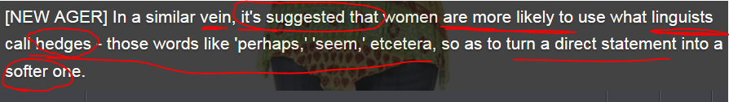





 “perhaps” is a “hedge”







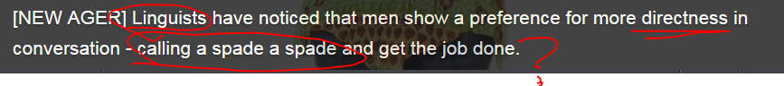

**直言不讳；实话实说: call a spade a spade**







For example:  ( I’m **beyond stresse[d o]ut; I’m totally frazzled['fræzld] 疲惫的)**





Man: “You should **take a breather**/short break or take a vacation”

Girl**: it’s not that so simple, OK?**





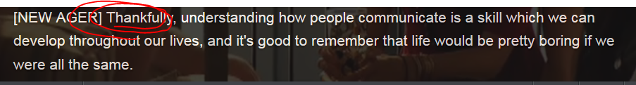

## 句尾附加疑问 a tag question

[ a tag question ] v.s. rhetoric question 反问句

e.g. Using **a tag question** is a good way to bring the other person into the conversation.

|  |  |
| --- | --- |
| A tag question | Rhetoric question |
|  | Why don’t want that **magic wand**? 魔术棒 |
| You don’t wanna go shopping with him, **do you?** | Why don’t wanna be a millionaire? |

## 2nd row Gestures and body language used in communication

 V.S. 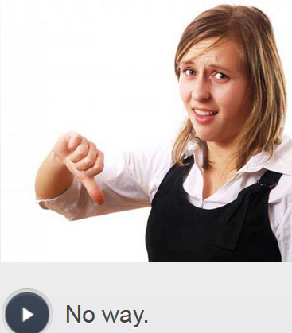

thumbs up = I approve, good V.S. thumbs down = No way.

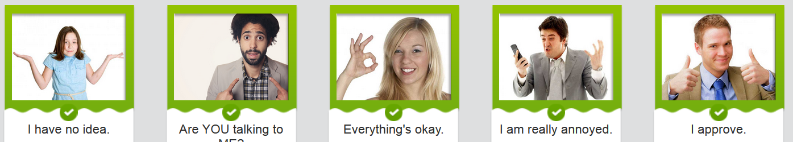

## 3rd row Using sarcasm 讽刺说反话 or humor in communication

Sarcasm讽刺, 说反话 is when someone says something that is **the complete opposite** /ˈɒpəzɪt/ of what they mean, in order to be funny or **insulting**/**mocking**. For example, you and a friend are having dinner in a restaurant and the waiter is very rude. Your friend points this out and you reply sarcastically:

|  |
| --- |
| A: That waiter is so rude. I can't believe it. |
| B: Yeah, I think he probably **runs a charm school礼仪学校**when he's not waiting tables. |
| A: I'm tempted to speak to the manager. |
| B: Or we could just ask him to **hang out with** us after he finishes work. |

There are different ways that sarcasm and humor can be used. Sarcasm can be used in a quite **hurtful/harsh/barbed尖酸刻薄** way, so be careful how you use it.

In addition to **ton[e o]f voice**, sarcasm also has to do with the words you choose. Look at the images and select the most sarcastic phrases.

## 4th row Communicating **indirectly** by using “hedges”

* Hedges 避免正面／直接的回答发言: e.g. Words like 'perhaps', ‘maybe’, ‘it’s likely that’, and 'seem' are called “hedges”, used to avoid a directness, esp. to avoid throwing a direct question or making a direct statement. “Hedges” can be used to **soften sb’s position or relent sb’s attitude (缓和).**

Normally, compared with men, in a similar vein, **it’s suggested that** women are more likely to use what linguists call “hedges” so as to turn a direct statement into a softer one.

V.S.

* Call a spade a spade: 直言不讳；实话实说 **( spade:  铁锹，铲子; shovel:  铁铲)** e.g. She always tells the truth, **calling a spade a spade.**  e.g. She never speaks directly. I'm always trying to **guess, conjecture 推测；揣摩 or infer推断**_ what she means. Well, I hope that she can **call a spade a spade**直言不讳；实话实说   
  E.g. He was born in LA, so his communication style is full **of** **exoticism** /ɪɡˈzɒtɪˌsɪzəm/ 异国风味/ 情调/洋派. Compared with local Chinese who are used to chatting with **hedges (“like”, “maybe”, “it seems”)** to avoid directness, he likes to communicate straightforwardly, mostly **calling a spade a spade**直言不讳；实话实说 (spade铲子, 黑桃牌)

|  |  |
| --- | --- |
| **Communicating indirectly** | |
|  | |
| Some people are direct and say exactly what they want or how they feel, which is named **“call a spade a spade直言不讳；实话实说**”. Other people communicate more indirectly by using the “hedges” skills避免正面／直接的回答／发言.  e.g.   |  |  | | --- | --- | |  | Direct: I want to move to an apartment closer to downtown. | |  |  |  |  |  | | --- | --- | |  | Indirect: Our apartment is quite far from downtown. |   e.g. | |
|  | Direct: This food is awful. The salad isn't even fresh. |
|  |  |

|  |  |
| --- | --- |
|  | Indirect: This food is not the best. The salad could be fresher. |

|  |  |
| --- | --- |
| Very often **indirect** communication depends upon a specific situation, or context. **Even though that indirect communication has less chance of startling or offending someone**, it also has a greater risk of being misunderstood. | |
|  | |
|  | Situation: You are in a small room with people who are smoking. |
|  |  |

|  |  |
| --- | --- |
|  | Indirect statement:  Maybe we could open a window or turn on the air conditioner. |
|  | Direct statement: I'd appreciate it if you'd stop smoking. |

## Hedging language

|  |  |
| --- | --- |
|  |  |
| One type of **indirect communication** is called **hedging**. Hedging is to qualify or modify a statement to avoid being too direct, **rigid死板的, hurtful/harsh/barbed刺耳的**.  Hedging makes a statement **less forceful, less assertive /əˈsɜːtɪv/坚定自信的, or less intense**. Some **hedging language** includes **I think/I’d like to point out that/It’s my contention that** , **It would seem**, **maybe**, **kind of**, **somewhat**, **sort of**, **I suppose** and **could be**. **Discourse marker**s such as 'I think' and 'It would seem' are ways to begin hedged sentences. | |

|  |  |
| --- | --- |
|  | A: I really want to go to the baseball game this weekend. We're going, right? |
|  | B: **It would seem ( “hedges”)**  that we're going. |
|  |  |
|  |  |

|  |  |
| --- | --- |
|  | A: Did you remember to pick up my suits from the cleaners? |
|  | B: **Well, I sort of ( “hedges” )** forgot because I was so busy. |

|  |  |
| --- | --- |
| If someone is being **so indirect (with many “hedges”)** that you are unclear of what they are saying, use these expressions to clarify or make sure what they mean: | |
|  | |
|  |  |

|  |  |
| --- | --- |
|  | **So, are you saying that** you can or you can't come? |
|  |  |

|  |  |
| --- | --- |
|  | **Do you mean that** you already bought the tickets? |
|  |  |

|  |  |
| --- | --- |
|  | **Am I understanding you correctly that** you want me to do the work for you? |
|  |  |

|  |  |
| --- | --- |
|  | **What exactly** are you saying? |

## mp3 video







## Video: 5th row

I just have so many things to do before leaving for my summer vacation. I don’t know what I’m going to do first.

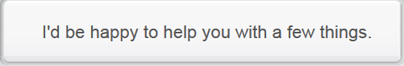

Really? That would be great. I still need a map of this area and a French dictionary as well.

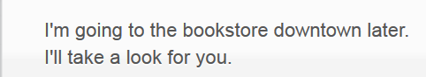

Thanks so much. I don’t know when I’ll do it without your help. Here comes my **heartfelt gratitude**.

**Hey, what are friends for? All you have to do is ask.**

Thanks. I don’t want to be any trouble, **though**. I know you’re busy, but there is one another thing.



Well, It’s my old cameras with pretty bad resolution. I hate taking bad pictures during my vacation.

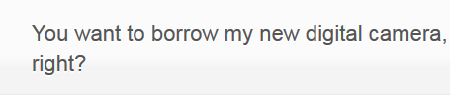

**Would you mind?** I will be really carefull and I will email you my pictures everyday.

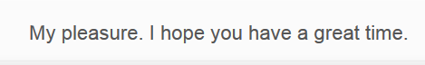

# Part 2) Non-verbal/silent communication

## 1st row) Non-verbal communication = silent communication by using gestures, eye contact, body language

Nonverbal communication is silent communication, and it includes the use of following non-verbal skills: gesture, eye contact, facial expression**, conversational distance 交谈的身体距离**, and intonation.

* **conversational distance 交谈的身体距离** e.g. The ordinary **conversational distance** in your country is much closer than it is in mine.
* Intonation V.S. ton[e o]f voice
  + Rising, plain, curve, falling intonation
  + Ton[e o]f voice: formal V.S. informal; [ hurtful/harsh and barbed ton[e o]f voice 尖酸刻薄的语气; sarcastic ton[e o]f voice 讽刺的语气; accusatory tone of voice: 非难的责难的语气]

## Stop) Lexical resource

* 1 摆脱困境，脱身；脱离危险；2 (电话听筒)未挂上 make sb. off the hook
* fax to sb.
* elicit /ɪˈlɪsɪt/

1.V-T If you elicit a response or a reaction, you do or say something that makes other people respond or react. 引起 (反应**) [ elicit a positive response; elicit a strong reaction = call forth ]** e.g. Mr. Norris said he was hopeful that his request would **elicit a positive response**. 他希望他的要求会**引出一个**积极的回应。

e.g. Sometimes, when you are pushed for time and just want to confirm something, a simple closed question will suffice [sə'faɪs] 满足(be sufficient or adequate in quality or quantity). For example, if you want to start a talk and are checking to see if the audience is ready, asking ‘Are you all ready to begin?’ will **elicit/call forth引出 a simple yes/no answer**. On the other hand, asking ‘How do you feel about beginning?’ gives audience members more of an option to delay, or to give rambling answers – not good when you are pushed for time.

If, however, your goal is to get detailed information from someone, an open question trumps a closed one each time. Say you’ve just delivered some important information and you want one of your colleagues to reinforce your message to the team – asking ‘Dave, can you explain to the group how you dealt with a similar problem last week?’ will **elicit/call forth引出 a detailed response**, whereas相比之下 asking, ‘Dave, would you agree?’ lets your colleague off the hook with a simple yes/no answer.

// 摆脱困境，脱身；脱离危险； (电话听筒)未挂上 off the hook

2.V-T If you **elicit a piece of information**, you get it by asking the right questions. 探得 (信息) e.g. My letters to her have elicited no response. 我写给她的信没有得到回应。

* 使sb 失去个性(某人的想法都不重要) sth depersonalize sb. /dɪˈpɜːs**nə**ˌlaɪz/

1.V-T To **depersonalize someone** means to treat them **as if** they do not matter because their individual feelings and thoughts are not important. 使sb 失去个性(某人的想法都不重要)   
e.g. She does not feel that **the book depersonalizes women.** 她没有感觉到这本书**使妇女失去了个性**  e.g. After she’ve got married for 7 years, the boring life hastotally **depersonalized her.**

1.V-T To [ **depersonalize a system or a situation** ] means to treat it **as if** it did not really involve people, or to treat it **as if** the people involved were not really important. 使(一个情况)不牵扯到具体的人； 使失去人性 [ **使战争失去了人性 depersonalize war**] e.g. It is true that modern weaponry **depersonalized war**. 确实是现代武器**使战争失去了人性**。

e.g. If you are concerned about members of your team arriving late for work, but you don’t want to **single anyone out,** it might be better to **depersonalize the situation**使(一个情况)不牵扯到具体的人 by saying: ‘Remember that we all need to be **punctual 准时的** by 8.30 every morning.’ Choosing this strategy, instead of saying ‘**You** all need to be in the office by 8.30 every morning’ ensures that no one feels ‘picked on’

* amenable /əˈmɛnə/  If **you are amenable to something**, you are willing to do it or accept it. 愿意的   
  e.g. The Jordanian leader **seemed amenable/willing to** attending a conference. 愿意去
* informality **[ɪnfɔr'mæləti]**  e.g. Phrases such as ‘like’, ‘talk about’ and ‘let’s say’ are often inserted into spoken English, especially by younger speakers. They add no extra meaning, but are used to convey **an air of informality [ɪnfɔr'mæləti]. //**一种(氛围vibe, feel）: an ai[r o]f sth
* **洋溢着(自信/幸福和开心); 慢慢的)渗出; 散发出(液体，气味)** exude /ɪɡˈzjuːd/     
  1. If someone exudes a quality or feeling, or if it exudes, they show that they have it to a great extent. 充分显露; 洋溢 **[ 洋溢着自信 exude confidence; 洋溢着幸福和开心exude happiness and gladness; 洋溢着一种(感觉) exclude an air of <a feeling/emotion> ]**   
  e.g. The guerrillas **exude confidence**. Every town, they say, is under their control. 这些游击队员们**洋溢着自信**。 E.g. She **exudes an air of** relaxed calm. 她**洋溢着一副/一种**从容平静的神情。  
   // 一种（氛围 vibe, feel）: an ai[r o]f sth  
    
  2. If something exudes a liquid or smell, odor or if a liquid/smell/odor exudes from it, the liquid or smell comes out of it **slowly and steadily**. (慢慢的)渗出; 散发出(液体，气味) **[ 散发出一种xxx气味 exude a stinky smell ]**e.g. Nearby was a factory which **exuded a pungent, stinky smell.** **散发出**一种刺鼻**气味**的工厂。
* **一种（氛围vibe，感觉，feel）: an ai[r o]f sth**   
  e.g. Phrases such as ‘like’, ‘talk about’, ‘you know’, and ‘let’s say’ are often inserted into spoken English informally, especially by younger speakers. They add no extra meaning, but are used to convey **an ai[r o]f informality [ɪnfɔr'mæləti]. 传达一种<不太正式的>感觉**
* 饥肠辘辘的; 饿极的 ravenous /ˈrævənəs/ ravenously

1.ADJ If you are ravenous, you are extremely hungry. e.g. I realized that I **had** eaten nothing since leaving home this early morning, and **I am so ravenous**. 她饿极了。 e.g. She began to eat **ravenously** = **devour/snarf down** the food 她开始**狼吞虎咽地吃**起来 =>  If a person or animal **devours something**, they eat it quickly, eagerly, **ravenously** / ˈ**rævənəs** /. 狼吞虎咽地吃

* affix:   
   v) affix sth to = attach to e.g. Affix **the parking permit** to the windscreen of your car

N)  词缀 An **affix** is a letter or group of letters, for example, "un-" or "-y," which is added to either the beginning (**prefix**) or the end of a word (**suffix**) to form a different word with a different meaning. For example, "un-" is added to "kind" to form "unkind."

Affix includes the following two formats:

* + Prefix:
  + suffix
* **温习加强(xxx知识/技能/语言技能） brush up on (knowledge, skills)** : If you brush up something or brush up on it, you practise it or improve your knowledge of it. E.g. I had hoped to brush up my Spanish. 我曾希望**提高一下我的西班牙语 brush up on sth**
* **hang loose: 保持平静; 轻松一下**

e.g. He could even **hang loose** when he went into the **creepy** cave当他走进**令人毛骨悚然的**的窟时，他依然能**保持平静**。 E.g. **I’m beyond stressed out；** I have to **hang loose** somewhere. 我已经 **鸭梨山大**了；我要找地方**放松一下**。

e.g. Oh man, Let’s just leave the exam alone. We'll go to the student **lounge休息室** and just **hang loose hang loose放松一下**; have a beer or two and watch the ball game on TV - I don't feel likes studying tonight.

## Video: Types of “non-verbal” /silent communications globally

Nonverbal communication is silent communication, and it includes the use of following non-verbal skills: gesture, eye contact, facial expression, conversational distance, and intonation.







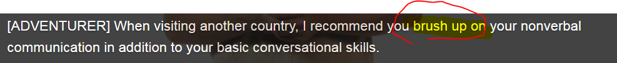



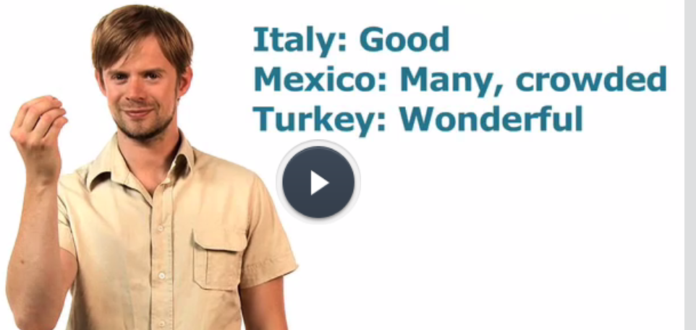 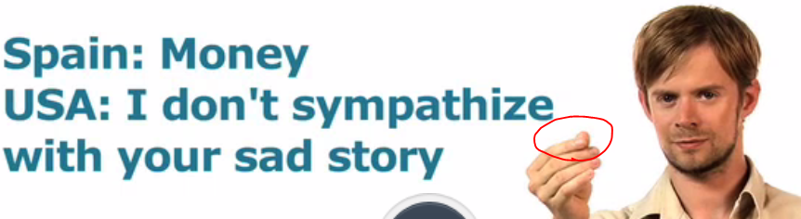

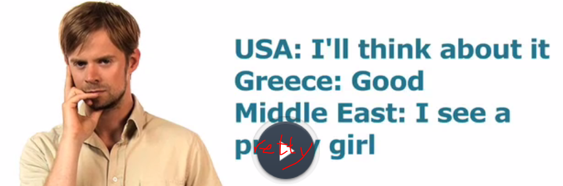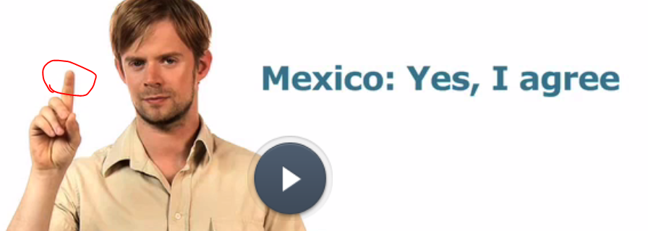

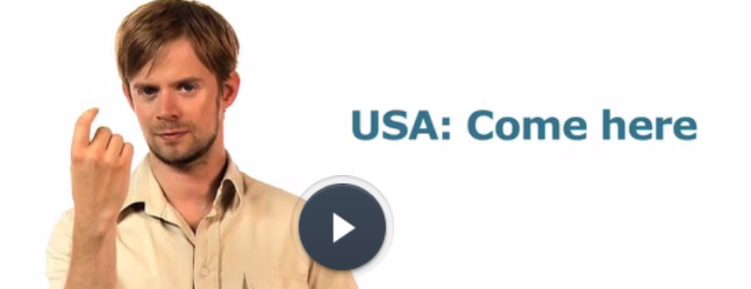 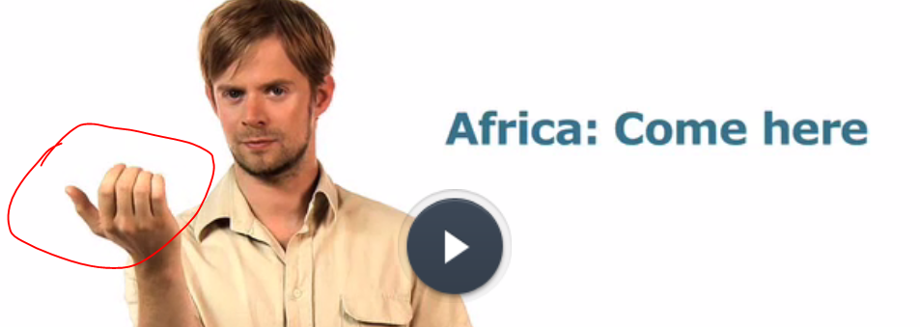

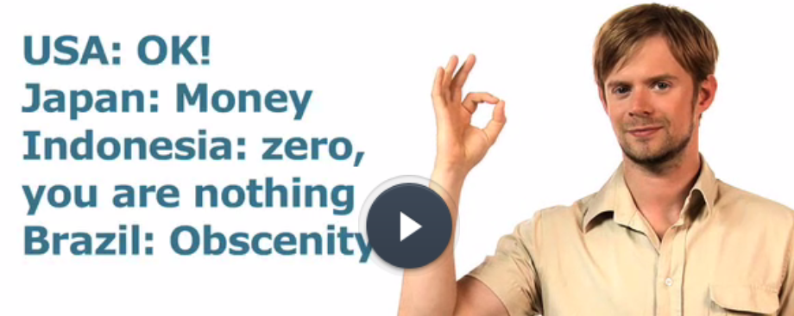 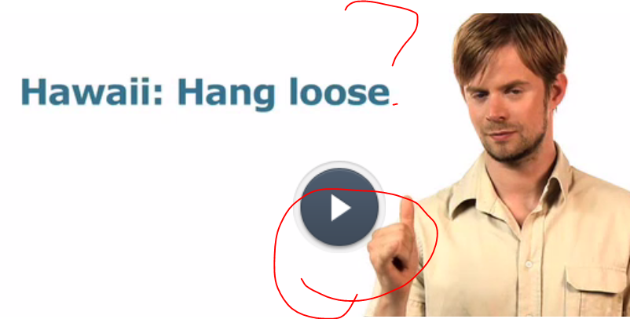

**hang loose: 保持平静; 轻松一下**

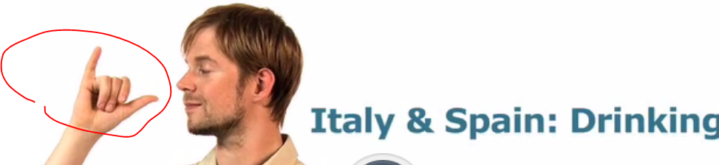 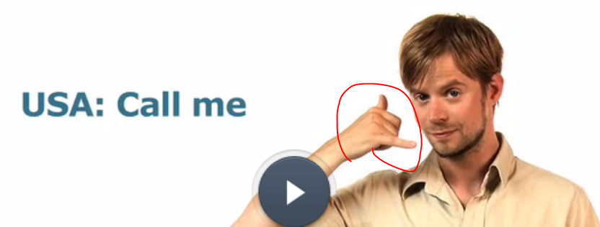

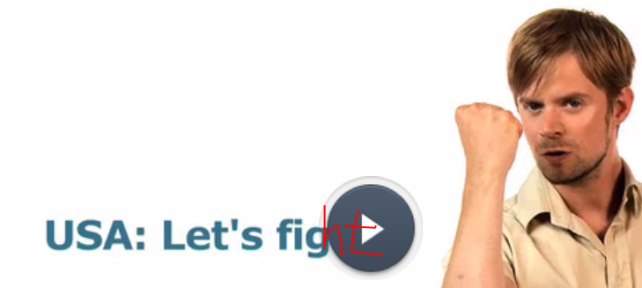 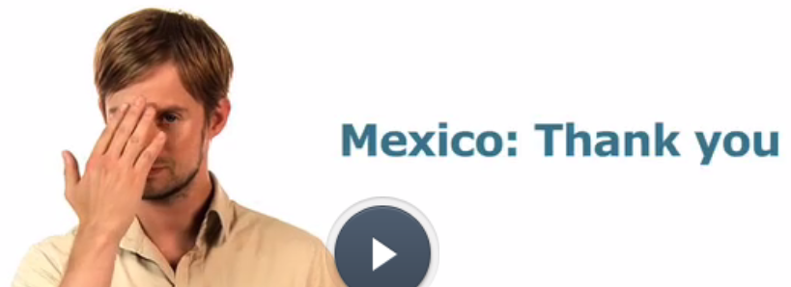

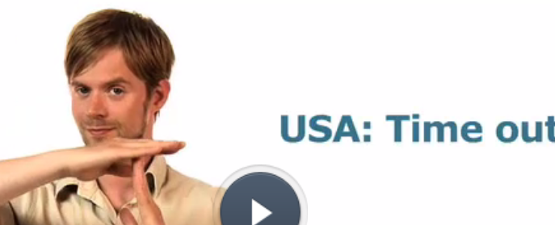 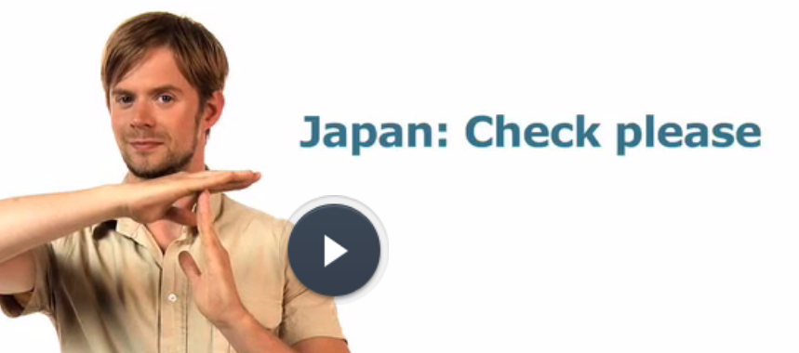

## 2nd row Development of English – affix

Affix: prefix (like “un”, “non”) and suffix (like “ness”, “ance”)

An **affix** is a letter or group of letters, for example, "un-" or "-y," which is added to either the beginning or the end of a word to form a different word with a different meaning. For example, "un-" is added to "kind" to form "unkind." Compare and . 词缀

English as we speak it today developed out of a variety of other languages, including so-called Romance languages such as French and Italian, Germanic languages and Scandinavian languages, amongst others. ‘Dead’ languages, such as Latin and ancient Greek, also played their part in shaping English and it is through Latin, in particular, that English developed its use of **'affixes'**. **Affixes** are groups of letters attached to the root of a word to form a new word. An example would be to take the adjective ‘happy’, and to alter it by adding the suffix ‘ness’ to form ‘happiness’. By doing so we change the adjective to a noun, and the **suffix ‘ness’** at the end of a word generally denotes that it is a noun describing a state of being, such as ‘loneliness’, ‘distractedness’, and so on. So **suffix** is a form of **affix**.

**Prefixes** are another form of **affix**, and they go at the start of a root. An example is ‘un’, which is generally used before adjectives to change them to their opposite meaning. For example, adding ‘un’ to ‘desirable’ gives us ‘undesirable’. Adding ‘un’ to ‘happy’ gives us ‘unhappy’.

In such a way, **affixes** add to the richness and variety of English, by giving us a flexible way to create new words and to change the meaning of existing ones.

## 3rd row Ton[e o]f voice: formal or informal English

**Ton[e of] voice**

**e.g. [ hurtful/harsh and barbed ton[e o]f voice 尖酸刻薄的语气; sarcastic ton[e o]f voice 讽刺的语气; accusatory tone of voice: 非难的责难的语气]**

Most languages have big differences in tone. Tone refers to **the leve[l o]f formality** used in the sentence. Generally, written English should be more formal than spoken English but much of it also depends on circumstance and context. For example, writing to your friend online while using MSN would require only informal language but having a chat with the Queen of England would require a very formal tone.

One situation (IM writing) can be informal and you don’t have to worry about things like spelling or precise grammar rules. The other kind (more formal) needs special words and more focus given to proper grammar. Also note that certain phrases in English are considered very **informal** and should rarely be used in a formal context, particularly in formal writing. For example, phrases such as ‘like’, ‘talk about’ and ‘let’s say’ are often inserted into spoken English, especially by younger speakers. They add no extra meaning, but are used to convey an air of **informality [ɪnfɔr'mæləti].**

Other things to avoid in formal English are phrases like ‘just’ or ‘totally’, which add an element of excitement and exaggeration that enlivens casual conversation, but which sound **unprofessional in formal situations.**

## Match the informal and formal equivalents

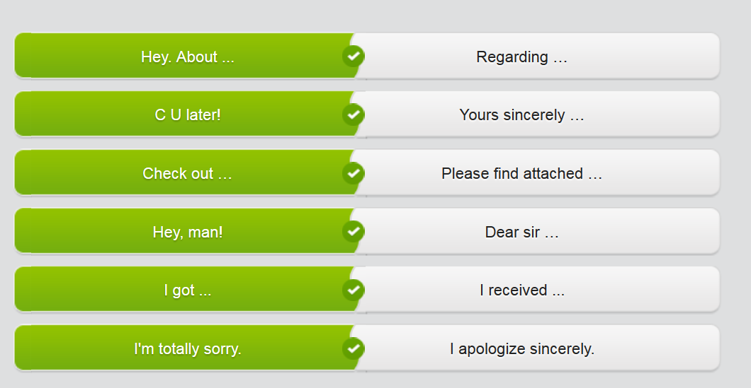

## 4th row Communication strategies

**Communication Strategies**

**Checking comprehension 理解力**

With language in constant evolution, it is always good to find ways to make sure that there is no misunderstanding. For that you need different communication strategies. Suppose that you have given instructions to a fellow employee and **you want to check that he or she has understood you**.

* A common strategy is to ask: ‘Did you understand?’, but this is a poor strategy, because the social pressure to respond ‘Yes, I did’ is so high that we often do not get a true response to the question.
* A better way to check others’ **comprehension理解力** is to ask something like: ‘Can you explain that back to me?’ or ‘So now I’ve explained, you show me what to do.’

**Use open and closed questions when appropriate**

Sometimes, when you are pushed for time and just want to confirm something, a simple closed question will **suffice [sə'faɪs] 满足( be sufficient or adequate in  in quality or quantity).** For example, if you want to start a talk and are checking to see if the audience is ready, asking ‘Are you all ready to begin?’ will **elicit/call forth引出** a simple yes/no answer. On the other hand, asking ‘How do you feel about beginning?’ gives audience members more of an option to delay, or to give rambling answers – not good when you are pushed for time.

If, however, your goal is to get detailed information from someone, **an open question** trumps a closed one each time. Say you’ve just delivered some important information and you want one of your colleagues to reinforce your message to the team – asking ‘Dave, can you explain to the group how you dealt with a similar problem last week?’ will **elicit/call forth引出** a detailed response, **whereas相比之下** asking, ‘Dave, would you agree?’ lets your colleague **off the hook** with a simple yes/no answer. // 摆脱困境，脱身；脱离危险； (电话听筒)未挂上

**Depersonalizing ( depersonalize sb: 使失去个性/没个性)**

Some listeners can be easily wrong-footed by too much use of the second person ‘you’. If you are concerned about members of your team arriving late for work, but you don’t want to single anyone out, it might be better to **depersonalize the situation（不要牵扯到具体的人）** by saying: ‘Remember that we all need to be **punctual 准时的守时** by 8.30 every morning.’ Choosing this strategy, instead of saying ‘You all need to be in the office by 8.30 every morning’ ensures that no one feels ‘picked on’.

**Involving the audience**

This sounds like a basic concept, but it’s one that most speakers forget, both when talking one-to-one and in large groups. Rambling on and on is a surefire way to encourage your audience to drift off and stop paying attention to what you are saying. **Keep your audience focused on your message by maintaining eye contact.** If you are addressing a room of people, look around the room regularly. Try to **elicit/call forth (引出)** nods or other gestures of understanding. If you don’t see any, it may be time to ask a comprehension question, e.g. “can you please describe it back to me? “.

## ?Open questions V.S. closed questions

Complete the phrases used to check understanding. As you do so, think about **which are open questions and which are closed.**

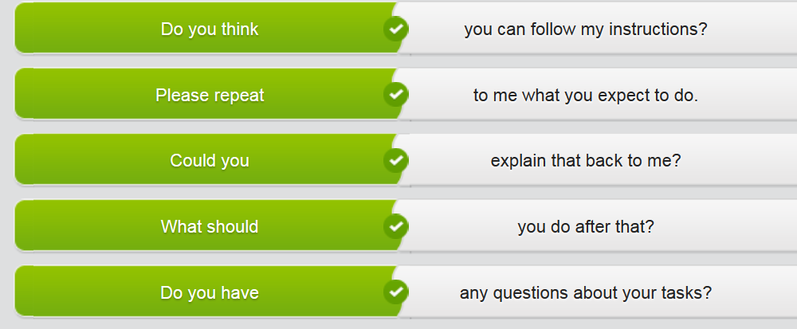

## Mp3 video:

## 5th row) Video: Communicate clearly

Your boss is giving you some instructions. Respond in a polite, respectful and appropriate way

# Part 3) Listen actively

## 1st row Body language

## Stop Lexical resource

* hog /hɒɡ/

1.N A hog is a pig. 猪 e.g. We picked the corn by hand and we fed it to the hogs and the cows.

我们掰下玉米，用来喂猪和奶牛。

2.V-T If you **hog something**, you take all of it in a greedy or impolite way. 独占/霸占xxx e.g. Are you done **hogging the bathroom**? 你要霸占浴室到什么时候？

3.PHRASE If you **go whole hog** or **go the whole hog**, you do something bold or extravagant in the most complete way possible. 彻底地干xxx算了 e.g. Well, I thought, I've already lost half my job, I might as well **go the whole hog** and lose it completely. 我还不如**彻底**放弃**算了**。

* What is turn-talking? know when it’s your turn to speak

• fidget fidget /ˈfɪdʒɪt/ TEM8 (fidgeting,fidgeted,fidgets)

* 1.V-I If you **fidget**, you keep moving your hands or feet slightly or changing your position slightly, for example, because you are nervous, bored, or excited. 动来动去

例：

Brenda fidgeted in her seat.

布伦达在椅子上坐不住。

* 2.PHRASAL VERB **Fidget around** and **fidget about** mean the same as . 动来动去 (同)(fidget)

例：

There were two new arrivals, fidgeting around, waiting to ask questions.

有两个新来的人，坐立不定，等着提问。

* 3.V-I If you **fidget with** something, you keep moving it or touching it with your fingers with small movements, for example, because you are nervous or bored. 不停摆弄

例：

He fidgeted with his tie.

他不停摆弄他的领带。

同近义词 同根词

词根：fidget

* adj.

[**fidgety**](javascript:void(0);) 不安的，烦躁的；难以取悦的

• your body and your soul

• Lean in

• get things off one's chest 敞开思想

## Types of body language

See “Types of body languages” in part 4

## Mp3 video: Using your body language

## 2nd row Communication strategies

See 1st part > 4th row, also “communication strategy”

## Mp3 video: 2ND/3rd tab





## 3rd row **Intonation with tag questions**

## 2nd tab: a tag question 附加疑问句



A tag question (e.g. aren’t you, don’t you) is used to involve another person to your conversion.

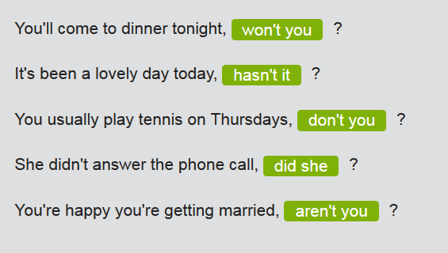

* Intonation: plain, rising intonation, curve intonation, falling intonation, which delivers or expresses the different meaning even for the same sentence
* Ton[e o]f voice: **; [ hurtful/harsh and barbed ton[e o]f voice 尖酸刻薄的语气; sarcastic ton[e o]f voice 讽刺的语气; accusatory tone of voice: 非难的责难的语气]**

**Rising intonation with a tag question:**

Use **rising intonation** with **a tag question** to confirm information you're **Uncertain about, esp for seeking an affirmation肯定 from others. A tag question is normally used to bring another person into a conversation.**

* He understood what I said, **didn't he?**
* She's good in cross-cultural situations, **isn't she?**

**Falling intonation with a tag question**

Use **falling intonation** with **a tag question** to confirm information you're **pretty certain about, or to seek agreement**

|  |  |
| --- | --- |
|  | * That presentation was excellent, **wasn't it?** |
|  |  |

|  |  |
| --- | --- |
|  | * He certainly gesticulates a lot, **doesn't he?** |

## Stop study Mp3 video: 4th row

Your friend Joe is in trouble with his girlfriend again. She has not talked to him for over a week. She says that there is no point talking to him because he never listens. Joe asks you for advice on how to be a good listener.

xxxxxxxxxxxxxxxxxxxxxxxxxx

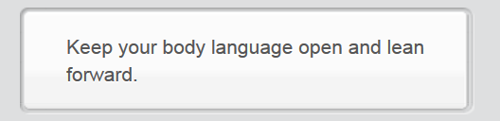

Wow, like this?

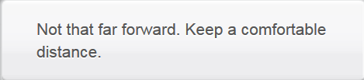

Xxxxxxxxxxxxxxxxxxxxxxxxx

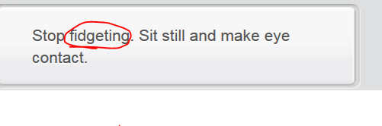

Like this?

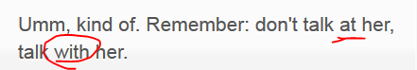

…

xxxxxxxxxxxxxxxxxxxxxxxxx

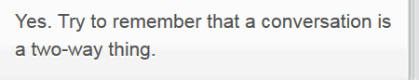

….xxxxxxxxxxxxxxxxxxxxxxxxx

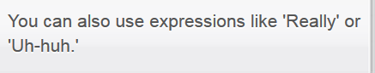

…xxxxxxxxxxxxxxxxxxxxxxxxx



# Part 4 ) Describe communication in your culture

## 1st row A linguistic view of the world

## Stop Lexical resource

thought-provoking

1.ADJ If something such as a book or a movie is thought-provoking, it contains interesting ideas that make people think seriously. (书籍、电影等)发人深省的; 引人深思的

例：

This is an entertaining yet thought-provoking film.

这部电影令人捧腹，却又发人深省。

双语例句 权威例句

1.

But in a society where homosexuality is punishable by death, the movie is thought-provoking.  [跟读](javascript:;)

但在一个同性恋可被处死的社会中，这部电影是发人深省的。

[article.yeeyan.org](http://article.yeeyan.org/bilingual/215637)

2.

The picture is thought-provoking, and what it illustrates is a common phenomenonin our society today.  [跟读](javascript:;)

这幅画是发人深省的，它所说明的是我们今天社会普遍存在的一种现象。

frown /fraʊn/

1.V-I When someone frowns, their eyebrows become drawn together, because they are annoyed, worried, or puzzled, or because they are concentrating. 皱眉

例：

Nancy shook her head, frowning.

南希摇摇头，皱着眉头。

He frowned at her anxiously.

他焦急地朝她皱了皱眉。

2.N-COUNT Frown is also a noun. 皱眉状态

例：

There was a deep frown on the boy's face.

那个男孩的脸上有深皱眉的表情

Sb frow[n o]n sth or frow[n u]pon sth

1.PHRASAL VERB If something is frowne[d u]pon or is frowne[d o]n, people disapprove of it. (皱着眉头)不赞成

例：

This practice is frowned upon as being wasteful.

这种做法被认为是浪费而不被赞成

* linguist; linguistic; linguistics:
* linguist 语言学家, linguistic语言的/语言学的, linguistic**s**语言学:  A **linguist**语言学家 is someone who studies or teaches linguistic**s**语言学.
* Lingua franca
* **lingua franca /ˈlɪŋɡwə ˈfræŋkə/**

A lingua franca is a common language or way of communicating which is used between people who do not speak one another's native language. (讲不同母语的人之间的)通用语 e.g. **Undoubtedly**, English has been the **lingua franca** of world for many years**. In this day and age**, mandarin is increasingly becoming the 2nd **lingua franca** in world. 英语正迅速成为世界的通用语

* perception: People with different culture might have different or even stark different perception of colors
* hypothesis; hypo’thetical, hypothetically, under assumption that xxx
* bands of a rainbow
* **attire 服装；盛装** **[ business attire 商务正装 ]** e.g. Attires may be considered disrespectful in some places. Moreover, the **communication distance**, (that is touching or being physically very close to the other person when speaking) may be perfectly acceptable in some cultures while really **intrusive 侵入性的 and offensive 攻击冒犯的** in other places.
* 本土的; 当地的 (人/土著；产品；食物) indigenous /ɪnˈdɪdʒɪnəs/ ,  Indigenous people or things belong to the country in which they are found, rather than coming there or being brought there from another country. The original people to inhabit a location are called indigenous   
  **[ 本土人口 indigenous population; 本土乳品业 indigenous dairy industry ]**e.g. Based on **population census人口普查**, the number of the country's indigenous population is only around 5000 …该国的本土人口
* **Communication distance**: that is touching or being physically very close to the other person when speaking.   
  E.g. Communication distance, that is touching or being physically very close to the other person when speaking, may be perfectly acceptable in some cultures while really **intrusive 侵入性的 and offensive 攻击冒犯的** in other places. It’s worth being aware of these communication **divergence**.
* **A diverge from B /daɪˈvɜːdʒ/, divergent /daɪˈvɜːdʒənt/, divergence**

1.V) If one thing (e.g view, point, idea, opinion)**diverges from** another similar thing, the first thing becomes different from the second or develops differently from it. You can also say that **two things diverge**. 相异 e.g. His interests increasingly **diverged from** those of his colleagues. 他和同事们的兴趣越来越不同 E.g. My life style, horizontal views, and sense of work totally **diverge from** zhanglu’s

2.V) If one opinion or idea **diverges from** another, they **contradict each other** or are different. You can also say that **[two opinions, views, or ideas diverge]. (两个想法，观点，意见)有分歧,相左**

* divergent /daɪˈvɜːdʒənt/ 有分歧的(想法/观点/意见); 意见相左的 **[ divergent views/ideas/opinions ]**

ADJ Divergent things are different from each other. E.g Two people who have **divergent views** on this question are George and Bob. 这个问题上**意见相左**的两个人是乔治·瓦特和鲍勃·马尔

* dialectical [,daɪə'**lɛktɪk**l] differences
* 有方言的 e.g. It’s hard for me to clearly understand key information delivered by his **commence speech 毕业演讲** because of his **dialectical accent 方言口音** e.g. I failed to grab his points in his **keynote speech** (党大会发言) because of his **dialectical accent.**
* In philosophy, **dia’lectical thought or dialectical theory** is used to describe situations, theories, and methods which depend on resolving **opposing factors**. 辩证的 **[ dialectical thought 辩证思想; dialectical theory 辩证理论] e.g. The essence of dialectical thought is division. 辩证思想的实质是二分法**
* **punctual, l ['pʌŋktjuəl, -tʃuəl]; punctuality [,pʌŋktju'æliti]:** is the quality of being punctual. 准时性; 规矩 e.g. The airline hopes to improve punctuality next year. 航空公司希望明年在 准点 上做出改善

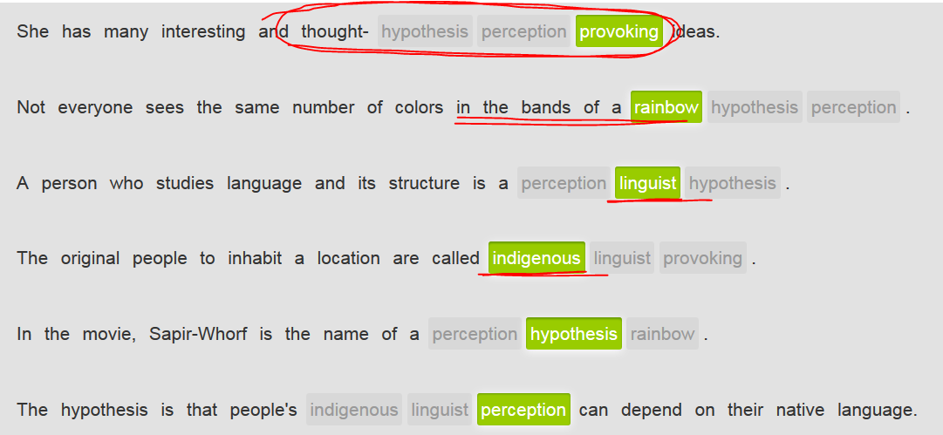

## mp3 Video

….

## 2nd row:

## Types of body languages

* Cross your arms: folding your arms across your chest and interlocking them. E.g You might cross your arms when you feel cold and wanna collect energy from the whole body

1. Maintain or make eye contact: looking someone in the eye when speaking with them. E.g. Making eye contact is very important during a job interview. E.g. making eye contact with your boss

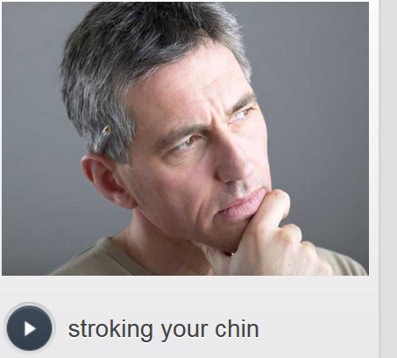 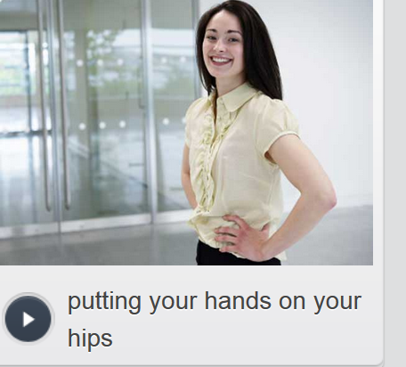 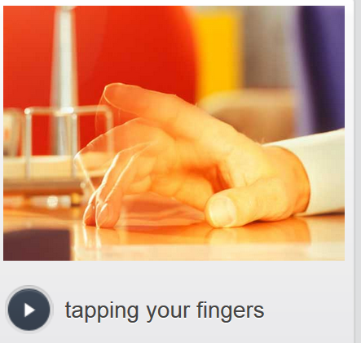

* **Stroke your chin**:   
  an often unconscious action **whereby/by which** a person uses the thumb and **forefinger/index finger** to rub his or her chin. This is often done when one is in deep thought or bored. **//sun-stroke 中暑**

e.g. Stroking your chin can make you look very serious. E.g. stroking your chin during the exam

* putting your hands on your hips: resting your hands on your hips with the elbows pointing out.
  1. Psychologists say that **putting your hands on your hips** makes you look powerful or have authority.
  2. Or maybe **putting your hands on your hips** while waiting in line
* 轻敲**tapping your fingers:** bringing your fingers up and down and slightly strike on a hard surface (e.g. desk) which makes a noise, usually following a pattern. **This is often done when someone is bored or nervous.**

e.g. Why are you always tapping your fingers? It's very annoying!   
E.g. I’m so nervous and I cannot help tapping my fingers on the table.

* **Lean (your body) forward**

## Types of hand gestures

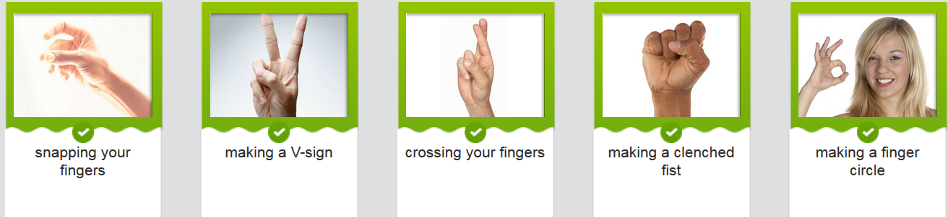

* **n) finger snapping: 打响指 v) snap your fingers**
  + In U.S. ,british: to reminder sb;
  + in Latin America: hurry up;
  + in Brasin: sth long long ago?
* **Cross your fingers:** 
  + In U.S. , good luck
  + In China, esp in come relatively unopen places, it might deliver the same intrusive and offensive meaning as pointing your middle finger at someone.
* Make a clenched fist: 紧握的拳头
  + In CHINA: fighting 加油
* **Waving your hands:**
  + is harmless for most Westerners. Westerners are normally waving their hands to call a taxi.
  + But it's a serious insult in Greece, Nigeria, Pakistan and some parts of Africa.
* The **thumbs-up**:
  + in Western culture equals a positive signal indicating a job well done.
  + **However**, in some cultures, mainly in Latin American countries, **this sign means the same as the middle finger. So be careful: you may be insulting someone.**
* **The thumbs-down**
  + **In China, look down upon sb.**
* The **finger circle:**
  + means something really good, or 'OK', in America and the UK.
  + It's considered obscene/offensive in Brazil or Germany **though**.
  + In Japan it means money.
* The V-sign
  + In America **the V-sign** with the palm faced outwards, and the palm inwards both mean victory.
  + However, if the outside of your hand faces your target, it's an insult in Great Britain.
* **Tapping your head:**
  + in some Latin American countries such as Argentina and Peru means 'I'm thinking' or 'think',
  + while in most other countries it means crazy.

## Mp3 Video: hand gestures



## 3rd row relative clauses定语从句

Some **relative clauses** provide essential additional information or complement补助 about someone or something. They identify which person or thing is referred to:

* Use the relative pronouns “that” and “which” to introduce **relative clauses** about things.
* Use the relative pronoun “where“ specifically to introduce **relative clauses** for places.
* The relative pronouns **who**, **whom**, **that** and **whose** introduce **relative clauses** about people.
  + **Whose** is used for possession.
  + **Whom** is used after **to** or **for**. **Whom** is also used when the pronoun refers to a noun that is the object of the clause.

|  |  |  |
| --- | --- | --- |
|  | | |
| In the sentence below, the clause **who always snaps his fingers打响指** tells you which customer the sentence is about. If you remove the clause, the sentence cannot be understood. This is why these clauses are called **defining**. In these kinds of sentences, there is no comma before the clause. | | |
|  |  |  |

|  |  |  |  |
| --- | --- | --- | --- |
|  | He's the customer **who always snaps his fingers.** | | |
| He's the man **whom** I met in Beijing last year | | | |
|  | |  |  |

|  |
| --- |
| In the above sentence **whom** refers to the man. **Man** is the object in the sentence, **I met a man, not a woman.** |
|  |

## Video) 2nd tab



Listen to the people using relative clauses. Decide if the clause you hear is defining or non-defining. Pay attention to whether the speaker pauses or not.

## Guidelines for effective cross-cultural communication

Each country and its culture has unique factors which may **hinder** effective communication. The communication process is filtered by a range of variables which include language (verbal), social organization and **nonverbal/silent communication** behavior.

Effective communication skills:

* Verbal communication:
  + A native speaker communicating with a non-native speaker of English should avoid the use of **idioms, slang and jargon**.
  + What is more, the native speaker should try to speak more slowly than normal.
  + Additionally, other obstacles to successful/effective communication are the use of names and titles, greetings, **punctuality** and certain rules to observe related to **hospitality** and gift giving.
* **Non-verbal communication/silent** communication:   
  Nonverbal behaviour/silent, such as body language (including hand gestures), clothing/**attire服装/盛装,** eye contact, touching, and conceptions of **personal space私人空间** or **communication distance** are all ways of non-verbal communicating information.

For details about these communication skills, see the following “4th row reading- such a useful and nice paper”

**In a nutshell**, **it's worth being** aware of cross-cultural differences when interacting with people from other cultures.

## 4th row reading- such a useful and nice paper

Communication is not carried out/implemented in an identical fashion from culture to culture. Even when the same language is used to communicate among people from different places, we may notice that each country and its culture have unique factors which may hinder proper and accurate communication. It’s very important to **become aware of** this as we **have to communicate accurately and precisely,** especially when dealing with business, politics or religion across cultures, so as to avoid conflict and misunderstanding.

As we know, each culture has its own set of values, often quite **divergent**   不同的; 有分歧的 from those values held in other cultures. The communication process is thus filtered by a range of variables which include language, social organization, and non-verbal communication.

Even in the case that we assume the use of English as a lingua franca to communicate across cultures, we should not **overlook/ignore** translation problems, **dialectical [,daɪə'lɛktɪkl]** differences, and wrong use of register or pronunciation. If a native speaker is communicating with a non-native speaker of English, he should avoid the use of idioms, slang and jargon and try to speak slower than usual.

A very important feature of cross-cultural communication is non-verbal behavior. Body language, clothing, eye contact, touching and concepts of personal space all communicate information. It's important to know the meaning of certain body language and gestures in various cultures. Similarly, certain **attire** 服装；盛装 may be considered **disrespectful** in some places. Moreover, the **communication distance(, that is touching or being physically very close to the other person when speaking)** may be perfectly acceptable in some cultures while really **intrusive进攻性的 and offensive** 冒犯性的 in other places.

Other factors which may create obstacles to effective communication are: the use of names and titles, greetings, **punctuality规矩 and certain rules** to observe related to **hospitality** and gift giving.

Cross-cultural misunderstandings frequently arise from a failure to recognize or understand any of the issues outlined above. Even though it’s impossible to know everything about every culture, **it’s at least worth** being aware of these differences when interacting with people from other cultures.

**//sth is worthwhile = it’s worth your money, effort, and time to do sth = it’s worth it.**

## Writing-sample

Describing communication in your culture. Write about communication in your culture. Do people **tend to communicate more directly or indirectly?** What kinds of **body languages, hand gestures** are common or **are frowne[d u]pon**(皱着眉头)不赞成? What advice about **communicating effectively** would you give to someone visiting your country?

Communication in my country is generally indirect. By that I mean that people don’t like to make direct statements for fear of intruding, offending, or upsetting others. This can sometimes lead to misunderstanding. You have to become skilled at reading between the lines to understand what someone is really trying to say.

Along with this indirect style of communication, goes a rather formal use of body language. People in my country don’t make a lot of gestures while speaking because most of Chinese are sort of introverted and they are not used to using the relatively a little more exaggerated body language. However, two hand gestures that we do often use are the thumbs-up and thumbs-down. Literally, ‘up’ indicates ‘Great. Well done or you’re awesome’. Obviously, ‘down’ means “Bad, awful”. I think the interpretation is the same as other countries globally.

In some countries, it’s common to put a hand on another’s shoulder, or even hug, but that kind of behaviour makes people feel offensive or uncomfortable in my country. You need to have known someone a long time before there is any **physical contact**, small **personal space**, or close **communication distance.**

The best advice I could give to someone visiting my country and want to communicate with local people here is, when first meeting sb. to hold back a little big. Watch what other persons do, and listen a lot. Rather than ask a lot of questions, wait to be asked questions. Moreover, like I said, try not to be too physical in your interactions.

## Writing-mine

communication in your culture.

1. Do people **tend to communicate more directly or indirectly**? : indirectly (indirectness by using **hedges**, likely, it seems that xx to avoid offending others; intrusive and offensive
2. What advice about **communicating effectively** would you give to someone visiting your country?
   1. Verbal communication: * native speaker slow down, use proper body lanage when non-native speaker expressed their confusions; * avoid slang, idiom, jargon, and dialect * try to ask their comprehension, so you can adjust your speed, the depth of information you want to deliver
   2. Non-verbal/silent communication: e.g. body language, including hand gestures; attire, conceptions of **personal space** or **communication distance**

=> 3 What kinds of body languages, hand gestures are common or are frowne[d u]pon(皱着眉头)不赞成?

* 1. Common: stroke your chin, thumbs-up, circle: good; but in Jap: money; or maybe intrusive in some euro countries.
  2. Are frowne[d u]pon: thumb-down, close communication distance, physical touching if not a familiar friend

**[Leading/introducing sentence]** The way of communication in my country is generally indirect **whereby** I mean that people, especially the indigenous, hardly make direct statements for fear of intruding or offending others. They’re used to communicating by using **hedges** to avoid directness. This indirect communication can sometimes hinder others’ comprehension or even lead others to misunderstanding. In this situation, how to enhance your communication skills to achieve an effective communication is a big challenge. Generally, communication skills involve both verbal and non-verbal skill.

**[Firstly],** During the **verbal communication**, the native speaker of Mandarin should avoid talking about idioms, slangs, or jargons, neither the dialect. Furthermore, the native speakers should slow down their speed when interacting with non-native speakers to enhance others’ comprehension.

**[Secondly]** Honing skills in **non-verbal communication** can also help effectively communicating with others. The silent communication skills include right body languages, including hand gesture, comfortable personal space and proper communication distance. **Last but not least**, wearing proper attires and behaving with decent etiquette, such as punctuality, also add a plus for an effective communication. For example, people in my country are not used to using the relatively more exaggerated body language while speaking because most of Chinese are introverted and inhibited. However, some common gestures, such as the thumbs-up, the circled finger, the finger snapping, are used a lot in routine communication. However, **it’s worth being aware** that the same gesture might deliver the different or even totally opposite meaning for people from other places or countries. For instance, typically, the circled finger, in most countries, means “OK”. However, it’s upsetting and annoying some Europeans and it indicates money in Japan.

Additionally, we should avoid impolite or offensive gestures, such as thumbs-down that means “bad, awful” in my country.

**[On this note, in a nut shell] ,** studying how to communicate effectively is worthwhile, which will help you to accurately understand others’ meaning when interacting with others, especially when you’re travelling in other countries of the different culture from yours. This can help you out of awkward situation most of time.

# ** CNN related news or podcasts about making a speech, e.g.

## STOP Lexical resources:

* **紧随(脚跟)…之后 On the heels of sth**

e.g. The news caused an outpouring of **heartfelt grief and condolences衷心的哀悼**  among celebrities, especially coming so soon **on the heels of紧随(脚跟)…之后** the death of Chris Cornell, a close friend of Bennington's who **committed suicide** in May. Bennington had reportedly performed Leonard Cohen's "Hallelujah" at Cornell's **memorial service.**

* molest sb (a female or a child ) /məˈlɛst/   1.V-T A person who molests someone, especially a woman or a child, interferes with them in a sexual way against their will. 对…性骚扰 (尤指妇女或孩子) molest a child **[ sexually molest sb: 对*sb进行* 性骚扰; molest a child** **猥亵 ]** e.g. He was accused of sexually **molesting a female colleague**, aka sexual harassment. 他被指控 **对*一名女同事进行* 性骚扰**。 =>
* [molestation](javascript:void(0);) 干扰，妨害；折磨；调戏
* molester  猥亵者；性骚扰者
* extradite /ˈɛkstrəˌdaɪt/  extradition

1.V-T If someone is extradited, they are officially sent back to their own or another country or state to be tried for a crime that they have been accused of. (因犯罪被)引渡 e.g. A judge agreed to extradite him to Texas. 一位法官同意将他引渡到德克萨斯州。

e.g A New York court turned down the British government's request for his extradition. 一个纽约法院拒绝了英国政府对他的引渡请求

* repatriate  [riː'pætrɪeɪt; -'peɪ-]  美 [,ri'petrɪet]  v. 遣返; n. 被遣返回国者

n. a person who has returned to the country of origin or whose citizenship has been restored

v. 1. send someone back to his homeland against his will, as of refugees

2. admit back into the country

1.V-T If a country repatriates someone, it sends them back to their home country. 遣返 e.g. It was not the policy of the government to repatriate genuine refugees. E.g. Today they begin the forced repatriation of Vietnamese boat people. 今天他们开始强制遣返越南船民。

3.V-T If someone repatriates money that is invested in another country, they change their investments so that the money is invested in their own country. 调资回国

* bail out (bailing,bailed,bails)

1.PHRASAL VERB If you bail someone out, you help them out of a difficult situation, often by giving them money. (常通过提供资金) 帮助…摆脱困境 e.g. They will discuss how to bail the economy out of its slump. 他们将讨论如何使经济走出低谷。

2.→see also   financial bailout

3.PHRASAL VERB If you bail someone out, you pay bail on their behalf. 把…保释出来 e.g. He has been jailed eight times. Each time, friends bailed him out. 他已经蹲过八次监狱。每次，朋友们都把他保释出来。

4.PHRASAL VERB If a pilot **bails out of an aircraft** that is crashing, he or she jumps from it, using a parachute to land safely. 跳伞逃生 e.g. Reid was forced to bail out of the crippled aircraft. 里德被迫从严重受损的飞机中跳伞逃生

* rein’carnate /ˌriːɪnˈkɑːneɪt/, reincar’nation [,riɪnkɑr'neʃən]

1.V-T If people believe that they will be reincarnated when they die, they believe that their spirit will be born again and will live in the body of another person or animal. 使转世; 使化身 e.g...their belief that human souls were reincarnated in the bodies of turtles. ...他们认为人的灵魂转世投胎到海龟身体里的信仰

* **heady /ˈhɛdɪ/  (headier,headiest)**

1.ADJ  A **[ heady drink:令人醉的饮品； 令人陶醉的气氛/音乐： heady atmosphere/music/vibe/ experience]** strongly affects your senses, for example, by making you feel so drunk or excited that that you find it hard to think clearly, **rationally, or sensibly** 令人陶醉的 e.g....in the heady honeymoon days just after their marriage. …在他们婚后令人陶醉的日子里   
=> **intoxicated**:   
1) feel intoxicated = extremely excited/thrilled.   
2) be intoxicated/drunk/**smashed (extremely drunk烂醉的)**   
3) If you **are intoxicated by or with something** such as a feeling or an event, you are so excited by it that you find it hard to think clearly, **rationally, or sensibly**. 被xxx给陶醉了 e.g. My cousins seem to have **become intoxicated by** their success. 已经被他们的成功陶醉了。

* humble, humbly /ˈhʌmbəl/ ( humbler, humblest)

1.ADJ A humble person is not proud and does not believe that they are better than other people. 谦卑的; 谦逊的 = humble= modest. e.g. Despite her success, Divya remains humble about her career and heady ascent(n, rising, climbing up). E.g. He gave a great performance, but he was very **humble**. 但他却很谦逊。 E.g "I'm a lucky man, undeservedly lucky," he said **humbly**. 他谦虚地说。

3.ADJ People with low social status are sometimes described as **humble**. (社会地位) 低下的(职位) e.g.：

Spyros Latsis started his career as a humble fisherman in the Aegean. 最初的职业是爱琴海的**一名地位低微**的渔夫。

4.ADJ A **humble** place or thing is ordinary and not special in any way. 普通的 e.g. There are restaurants, both **humble** and expensive, that specialize in noodles. 既有普通的也有昂贵的专营面条的餐馆。

5.**ADJ [ 以我的愚见, 以我之拙见 In my humble opinion = IMHO]** People use a phrase such as **“In my humble opinion**” as a polite way of emphasizing what they think, even though they do not feel humble about it. e.g. It is, **in my humble opinion**, perhaps the best steak restaurant in the city. **以我之拙见**，它也许是该市最好的牛排馆。 => So **[** may I **humbly** suggest that**]** we all do something next time. 我可否 **愚拙地** 提议 **[ So, may be humbly suggestion that xxxx ]** ….

7. 认错, 赔礼道歉 If you**[ eat humble pie ]**, you speak or behave in a way which tells people that you admit you were wrong about something, just apologize. e.g. Even though I don’t think I did anything wrong, I **was forced to eat humble pie and publicly apologize to her.** 安森被迫认错并公开向她道歉。

8.V-T 轻易击败 (重要或强大对手); 一举击垮(重要或强大对手) If you **humble someone** who is more important or powerful than you, you defeat them easily. e.g. Honda won fame in the 1980s as the little car company that **humbled the industry giants**. 本田作为一家小型汽车公司因 **一举击垮行业巨头** 而声名鹊起。

9.V-T If **something or someone humbles you**, they make you realize that you are not as important or good as you thought you were. 使sb. 感到惭愧/自感惭愧 e.g. Ted's words humbled me. 特德的一席话使我自感惭愧。

10.ADJ 使羞辱的/自尊心受挫(经历) humbling **[ 一次令自尊心受挫的经历a humbling experience ]** e.g. Giving up an addiction is a humbling experience. 戒掉一种嗜好是 一次令自尊心受挫的经历

* Two people were killed when a small plane made an emergency landing at a beach in Portugal. A teenage girl was also slightly injured while **dodging** the plane. **//dodge sth: make a sudden movement in a new direction so as to avoid sth**
* **foiled/thwarted/failed** **[ a foiled/thwarted terror plot ]**   
  e.g. Australian authorities arrested four men Saturday over a **foiled/thwarted/failed** a **terror plot/** **conspiracy** to bring down an airplane.
* 尿布; 纸尿片 /ˈdaɪəpə/ A diaper is a piece of soft towel or paper, which you fasten around a baby's ass in order to contain its urine and **faeces['fisiz] 粪便**. [change the baby’s diaper换尿布]
* feces or faeces: is the solid waste substance that people and animals get rid of from their body by passing it through the anus. 粪便
* "Singapore is a good first step," said Booker, adding that the small state's e-commerce market "is still in its **infancy婴儿期, 初期**." Low said Prime will be available in Singapore soon, but wouldn't **elaborate on** timing or price **对…作详细说明**.
* Censor: If someone in authority censors a book, play, or film, they officially examine it, alter or change, delete or cut out any parts that are considered to be immoral or inappropriate. After censorship, the original interpretation that was expected to be delivered by the book/movie is usually changed to some degree. 审查 (书刊、剧本、电影)
* **Singaporean [,siŋɡə'pɔ:riən] dollars**
* **consulting firm咨询公司** e.g. Bain & Company
* **[ a backlash against sth/sb ]** A backlash against a tendency or recent development in society or politics is a sudden, strong reaction against it, esp strong disapproval, dislike, or dissatisfaction against it (对政治或社会变化的) 强烈反应, 激烈的反对/强烈抵制; 反冲 e.g. ..the male who has **a backlash against** feminism.…男性对女权主义的强烈反对 e.g. Muhammad, 24, said he was worrie[d a]bout **a backlash(激烈的反对/抵制) against** Muslims in Australia after Saturday's arrests. "Everyone will see us as terrorists and we're not," he said.

V.S.

* **boycott /ˈbɔɪkɒt/**1.V-T If a country, group, or person **boycotts a country, organization, or activity**, they refuse to be involved with it in any way because they disapprove of it. 联合抵制 E.G. The main opposition parties are **boycotting the elections**. **联合抵制**选举。  
  2.N)  Boycott is also a noun. 联合抵制 E.G. Opposition leaders had called for **a boycott of the vote**. 反对派领导者号召 **联合抵制投票**。
* (设备，装备，措施) (到位了) **sth is put in place** e.g.Police said **a comb-through searches 地毯式搜索**were also carried out in the Sydney **suburbs/outskirts** of Lakemba, the small city where the security level has been escalated to **the state of emergency**. The Prime Minister said extra security measures have **been in place (到位了)** at Sydney Airport since the **foiled/thwarted/failed** terror plot Thursday and have since **been put in place** at other major airports.
* parole [pə'rəʊl] V.S. parade [pə'reid] (Disney **floats花车 parade**)游行；阅兵,阅兵场:

1.N If a prisoner is given **parole**, he or she is released before the official end of their prison sentence and has to promise to behave well. 假释 e.g. Although sentenced to life, he will become eligible for parole after serving 10 years. 尽管被判无期，服刑10年后他将有资格获得假释。

2.PHRASE If a [ **prisoner is on parole ],** he or she is released before the official end of their prison sentence and will not be sent back to prison if their behaviour is good. 获假释 e.g. The **assailant攻击者** **[ə'selənt],** who was known to police and out **on parole假释出狱**, was shot dead after he ended a **standoff** by bursting out of an apartment.

3.V-T If a prisoner is paroled, he or she is given parole. 获假释 e.g. He faces at most 12 years in prison and **could be paroled** after eight years. 可以在8年后**获得假释**。

* [对（国家）**无理由的**强加制裁 **slap** sanctions against a country ]

e.g. House and Senate Republicans have reached a deal that is **paving the way to** send a bill to President Donald Trump's desk that **slaps new sanctions against** Russia and limits Trump's ability to remove them.

* paparazzi [,pɑːpə'rɑ**ːtsiː**] n. 狗仔队（专门追逐名人偷拍照片的摄影者或记者，paparazzo[,pɑ:pə'rɑ:**tsəu**] 的复数 e.g. Yangmi, one of the most **sought-after** 吃香actresses in CHIAN, said that she has been **getting fe[d u]p with/sick of** the **dreaded paparazzi’s eavesdropping** 令人讨厌的狗仔窃听.
* Beverly ['b**e**vəli] Hills 比佛利山庄
* foray /ˈfɒreɪ/

1.N If you [ **make a foray into** a new or unfamiliar type of activity] , you start to become involved in it. **涉足，初次尝试(某个新的/不熟的领域/行业)** eg. Amazon is rolling into Singapore, **marking its first foray** **into** Southeast Asia. E.g. Emporio Armani, the Italian fashion house, **has made a discreet谨慎 foray into** furnishings. 阿玛尼已谨慎地**涉足**室内装饰业。

2.N You can refer to **a short trip** that you make as a **foray** if it seems to involve excitement or risk, for example, because it is to an unfamiliar place or because you are looking for a particular thing. **(带有刺激性或冒险性的) 短程旅行 [ make a foray into a place ]** e.g. Most guests **make at least one foray into** the town. 大多数客人至少去过一次城里。

3.N If a group of soldiers **[ make a foray into enemy territory ],** they make a quick attack there or raid there by a quick invasion, and then return to their own territory. (对敌人领地的)突袭 e.g. These base camps were used by guerrillas to **make forays into** Turkey. 游击队用来**对土耳其进行突袭 //**

* Gorilla n. [动]大猩猩[ɡə'rilə] V.S. guerrilla 游击队
* **[ Population census ]** A census is an official survey of the population of a country that is carried out in order to find out how many people live there and to obtain details of such things as people's ages, gender, and jobs. 人口普查 **[ target demographic （影视/新闻/节目）的目标群众]**
* **Censorship** is the censoring of books, plays, movies, or reports, especially by government officials, because they are considered immoral or secret in some way. **(官方对书刊、剧本、电影或新闻报道的) 审查** e.g. The government today announced that press **censorship** was being lifted.新闻审查
* **v) trade barbs; n) trading barbs**e.g In the movie they play a couple who spend the evening **trading vicious barbs**, which brought the horror and fascination of their guests.  E.g. 两人整晚都在**恶语相向**，使他们的客人们既感惊恐又感迷惑。 E.g. After a day **of [ trading barbs (n)恶语相向],** House Majority leader and Senate Foreign Chairman **reached a consensus一致**Wednesday on the legislation for **new sanctions slapped against Russia (**对（国家）无理由的强加制裁**)**.
* **rebuke sb. /rɪˈbjuːk/**

1.V-T If you **rebuke someone**, you speak severely to them or criticize them severely because they have said or done something that you do not approve of. 谴责 V.S**. denounce sb (强烈)谴责** e.g. The president **rebuked the House** and Senate for not passing those bills within 100 days. 谴责参众两院xxx

2.N-VAR Rebuke is also a noun. 谴责 e.g. His statements drew a stinging rebuke from the chairman. 他的申明受到了主席严厉的谴责。

* **veto-proof (防否决的；(拥有足够的可能票数)确保能不被否决的)**

e.g. The original bill, however, passed the Senate 98-2 last month, which means Congress will have a significant **veto-proof (防否决的；(拥有足够的可能票数)确保能不被否决的)** majority.

* **抢镜[ Steal the spotlight ]** e.g. Princess Charlotte **steals the spotlight** on royal tour in Germany
* **抢了某人的风头**/credits : Steal sb’s thunder
* 支持/加强巩固 **Shore up sth:** **[ shore up sb’ position; shore up sb’s power ] If** you shore up something that is weak or about to fail, you do something in order to **strengthen, enhance, bolster** or support it. e.g. The democracies of the West may find it hard to **shore up** their defences. 很难加固自己的防御
* **bolster** /ˈbəʊlstə/  
  1.V-T If you bolster sth such as someone's confidence or courage, you **ramp up / increase** it. 增强 **[ 增强自信心bolster sb’s confidence; 增强某人的勇气: bolster sb’s courage ]** e.g. Hopes of an early cut in interest rates bolstered/increase confidence. 增强了信心。  
  2.V-T If someone tries to**bolster their position/power= shore up sb’s position/power** in a situation, they try to **shore up/strengthen/consolidate** it. 支持/加强巩固(sb’s 地位，力量, 经济) e.g. The country is free to adopt policies to **bolster/shore up/enhance its economy**. 来加强巩固经济。  
  3.N-COUNT A bolster is a firm pillow shaped like a long tube which is sometimes put across a bed instead of pillows, or under the ordinary **pillows. 长枕**

## Aviation – A foiled/thwarted/failed **terror plot** planned in aviation

<http://edition.cnn.com/2017/07/29/asia/australia-airplane-terror-plot/index.html>

Australian authorities arrested four men Saturday over a **foiled/thwarted/failed** a **terror plot/** **conspiracy** to bring down an airplane, Prime Minister said. Police said it was an Islamist-inspired **plot**, but they did not link the plan to a specific terrorist group.

Officers became aware that people in Sydney were **allegedly** planning to carry out a terrorist attack using an "**improvised device,"** Australian Federal Police Commissioner said. Turnbull described it as an **elaborate** conspiracy that involved bringing down an airplane.

The number one priority of my Government, and my commitment to the Australian people, is to keep them safe. The suspects were **rounded up** in raids in four Sydney **suburbs/outskirts['aʊt'skɝts]郊区** , federal police and the New South Wales Police Force said in a press conference **记者发布会**. They are in custody but have not been charged, Colvin said.

A house in the **suburb/outskirt**['aʊt'skɝts] 郊区 of Surry Hills, where one of the suspects was **arrested/apprehended,** remained **cordoned off 警戒线戒严**Sunday, with two police officers stationed outside.

More police **personnel** were parked in a nearby **alley/lane** 小巷；小路 and investigators appeared to be examining the property. Muhammad, 24, said he was worrie[d a]bout **a backlash(激烈的反对/；强烈抵制; 反冲) against** Muslims in Australia after Saturday's arrests. "Everyone will see us as terrorists and we're not," he said.

Police said **a comb-through searches 地毯式搜索**were also carried out in the Sydney **suburbs/outskirts** of Lakemba, the small city that has been announced to be in **the state of emergency**. The Prime Minister said extra security measures have **been in place (到位了)** at Sydney Airport since Thursday and have since **been put in place** at other major airports.

Last month, ISIS **claimed responsibility for** an attack at a suburban Melbourne apartment building where one man was killed and three police officers were wounded. The attacker/**assailant**攻击者[ə'selənt], who was known to police and out **on parole假释出狱**, was shot dead after he ended a **standoff** by bursting out of an apartment.

## Amazon is rolling into Singapore, marking its first **foray 涉足/初次尝试 into** Southeast Asia.

<http://money.cnn.com/2017/07/26/technology/business/amazon-singapore-launch/index.html>

* [ **make a foray into** a new or unfamiliar type of activity], you start to become involved in it. **涉足，初次尝试(某个新的/不熟的领域/行业)**

Amazon, the e-commerce giant launched its two-hour delivery service Prime Now in Singapore on Thursday, offering tens of thousands of products -- everything from digital cameras **to diapers 尿布**to instant noodles -- for speedy delivery. It’s the first time for Amazon to **make a foray into** Asia.

Singapore's "**population density** works really well for us," said Asia Pacific director of Amazon. Singapore packs/populates more than 5.6 million people into an area about half the size Los Angeles. "For the first time, we can launch [Prime Now] and have it open to the entire country at the same time," Low said.

The service is free for orders that cost at least 40 **Singaporean [,siŋɡə'pɔ:riən] dollars ($29).** For an extra 10 **Singaporean dollars** ($7.37), shoppers can get their goods in an hour. Amazon (has been **teasing** the launch **on social media** for the last few days, **enlisting** **influential** Singaporean Instagram users to [post photos](https://www.instagram.com/p/BW15yBqgprd/?tagged=dontsaybojio) of the [seemingly random contents](https://www.instagram.com/p/BXAEBBVjiov/?tagged=dontsaybojio) of a Prime Now package.

The Seattle company will be going up against local rivals like Lazada, which is **bankrolled** by deep pocketed Chinese e-commerce giant Alibaba. Lazada currently offers same-day service for several thousand products. But Amazon "**has deep pockets and takes no prisoners**," said Mike, partner with **consulting firm咨询公司** Bain & Company. The online retailer **is "probably keen to go** up against Alibaba in a contained environment and try out its strategies and offerings."

Amazon is using its massive new **warehouse** in Singapore for Prime Now deliveries. Amazon also has brand recognition on its side. The company is leading in innovation with products and services like Echo and Prime. Southeast Asia's e-commerce industry pulled in $15 billion last year, and the number of digital consumers has **increased/skyrocketed/hiked/soared高涨** by 50% this year, according to a recent report from Bain, one of the most famous **consulting firm**.

"Singapore is a good first step," said Booker, adding that the small state's e-commerce market "is still in its **infancy婴儿期, 初期**." Low said Prime will be available in Singapore soon, but wouldn't **elaborate on** timing or price **对…作详细说明.**

# Stop review:

## Scientists edit disease-causing gene mutation in human embryos

<http://edition.cnn.com/2017/08/02/health/crispr-human-embryos-gene-editing-study/index.html>

(CNN)Scientists are getting one step closer to snipping inherited genetic diseases out of human offspring using a gene-editing technique called CRISPR.

For the first time, scientists said, they corrected a gene mutation linked to inherited heart conditions in human embryos using the approach. A study demonstrating the technique was published in [the journal Nature on Wednesday](http://i2.cdn.turner.com/cnn/2017/images/08/02/nature23305_proof4.pdf) (PDF).

Last week, the [MIT Technology Review](https://www.technologyreview.com/s/608350/first-human-embryos-edited-in-us/) released the first news of this scientific feat, describing the research as the first-known attempt at creating genetically modified human embryos in the United States.

However, Juan Carlos Izpisua Belmonte, a co-author of the study, described it as the first in the world to demonstrate gene-editing to be safe, accurate and efficient in correcting a pathogenic gene mutation in human embryos. Previous attempts by Chinese researchers were unsuccessful at achieving this without safety concerns.

"This is the first that has been demonstrated as safe and working," said Belmonte, a professor at the Salk Institute for Biological Studies' gene expression laboratory in La Jolla, California.

"All cells of the embryo were corrected," he said. "It seems to be working from these samples that we have chosen, but we need to do much more basic research with many other genes."

The study was a collaboration between the Salk Institute, the Oregon Health & Science University in Portland and Korea's Institute for Basic Science.

Scientists estimate that more than 10,000 human diseases may result from mutations to a single gene occurring in all cells of the body, according to the [World Health Organization](http://www.who.int/genomics/public/geneticdiseases/en/index2.html).

Cutting and correcting gene mutations

The study used 75 human zygotes in which the father carried a mutation on the MYBPC3 gene, Belmonte said. The eggs used to produce the zygotes did not carry that gene mutation. The researchers noted that they received informed consent from the donors of the eggs, sperm and embryos used in the study.

The goal was to correct a type of inherited heart condition. A mutation called [MYBPC3](https://ghr.nlm.nih.gov/gene/MYBPC3#conditions) is associated with inherited heart conditions, including [left ventricular noncompaction](https://ghr.nlm.nih.gov/condition/left-ventricular-noncompaction), [familial dilated cardiomyopathy](https://ghr.nlm.nih.gov/condition/familial-dilated-cardiomyopathy) and [familial hypertrophic cardiomyopathy](https://ghr.nlm.nih.gov/condition/familial-hypertrophic-cardiomyopathy), which affects an estimated one in 500 people worldwide.

Hypertrophic cardiomyopathy also is thought to be the most common inherited or genetic heart disease in the US, according to the [Centers for Disease Control and Prevention](https://www.cdc.gov/heartdisease/cardiomyopathy.htm).

Newly fertilized eggs before gene editing, left, and embryos after gene editing and a few rounds of cell division.

In a lab dish, the researchers used CRISPR, a gene-editing technique,to remove the harmful MYBPC3 mutation from the human zygotes. Then, the zygotes' own DNA-repair mechanism replaced what was cut out with a copy of a MYBPC3 gene from the mother, which did not carry a mutation, Belmonte said.

"A male research subject known to be heterozygous for this gene mutation was recruited for the study, as were several healthy young egg donors," Dr. Paula Amato, an obstetrician-gynecologist at Oregon Health & Science University, said Tuesday. She was a co-author of the study.

"CRISPR was introduced at the time of sperm injection," she said. "Then, DNA repair of the embryos was assessed."

The researchers found that about 72% of zygoteswere properly and safely corrected on the MYBPC3 gene, Belmonte said.

This method significantly differed from studies in which scientists used the CRISPR tool to replace what was cut out with whatever the scientists desired.

Researchers in China were the first to reveal attempts to modify [genes in human embryos using CRISPR](http://www.cnn.com/2016/11/15/health/china-human-gene-testing-crispr-cas9/index.html). Three [separate studies](https://link.springer.com/article/10.1007%2Fs00438-017-1299-z) [were published](https://link.springer.com/article/10.1007%2Fs10815-016-0710-8) [in scientific journals](https://link.springer.com/article/10.1007%2Fs13238-015-0153-5) describing Chinese experiments on gene editing in human embryos.

"The previous human studies done in China had very small numbers, and one of them used abnormal embryos," Amato said. "So we think this is the first, largest study from which you could draw some reasonable conclusions."

Some gene-editing attempts in human embryos have been problematic, resulting in an issue called [mosaicism](https://medlineplus.gov/ency/article/001317.htm), in which the corrections made in one gene failed to replicate once that cell divided into two cells, those two cells divided into four cells and so on.

"So when the baby is born, all the cells do not have the mutation anymore. ... This study, it shows that we can correct the embryo and then, after the division, all the cells are corrected, so there's not what we call mosaicism," said Belmonte, who is also a member of the National Academies of Sciences, Engineering and Medicine's committee on human gene editing.

This year, the academies published a [report on human genome editing](https://www.nap.edu/catalog/24623/human-genome-editing-science-ethics-and-governance) that addressed potential applications of the technology, including the possible prevention or treatment of inherited diseases or conditions.

The future of gene editing

Though the researchers have expressed enthusiasm around their new study, they also noted that the findings must be replicated in followup research before this gene-editing approach can move forward to clinical trials.

"The fact that it is, apparently, a new and poorly understood mechanism and it is not the now standard CRISPR 'cut and replace' method adds to the time needed for research into its safety and effectiveness," said Hank Greely, professor of law and genetics at Stanford University, who was not involved in the new study.

Yet future research can come with some political challenges, Amato said.

"First of all, there are regulations regarding use of federal funds for embryo research, so the (US National Institutes of Health) does not currently support embryo research, so that's one barrier. The other barrier is, the (US Food and Drug Administration) is prohibited from considering any clinical trials related to germline genetic modification," she said.

In this new study the embryos were only allowed to mature to day three after fertilization before they were disaggregated, or isolated into various components, for further analysis.

In the far-off future, a clinical trial could include transplanting corrected embryos into a uterus with the goal of establishing pregnancy and then monitoring the embryos as they develop into children.

Still, "it is way too early to contemplate implanting the edited embryos for the purpose of actually establishing a pregnancy," said Dana Carroll, a professor of biochemistry at the University of Utah who was not involved in the new study but has used CRISPR in his own research.

"The genome editing tools are currently not sufficiently efficient and specific to be reliable, and regulatory and oversight processes have not been established," Carroll said, adding that the work on the new study was "well-done" and "well-presented."

"The authors have made an important discovery regarding the repair of CRISPR-induced DNA breaks in human eggs just at the time of fertilization," he said.

"This information will help to guide ongoing research, and it demonstrates that research on early-stage human embryos will be necessary to establish safe and effective procedures in the long run," he said. "There is still a lot of work to do to understand repair processes in very early embryos and to optimize the use of the CRISPR reagents, but this study makes a valuable contribution."

Some CRISPR critics have argued that gene editing may give way to eugenics and to allowing embryos to be edited with certain features in order to develop so-called [designer babies](http://www.cnn.com/2015/12/03/health/designer-babies-gene-editing/index.html).

However, the researchers wrote in their study that they hope CRISPR could be considered as an alternative option to preimplantation genetic diagnosis, also known as PGD, for couples at risk of passing on an inherited disease.

'This opens up the possibility for those embryos'

PGD, [developed about a quarter-century ago](https://www.ncbi.nlm.nih.gov/pmc/articles/PMC4449675/), is a genetic testing procedure typically conducted after in vitro fertilization to [diagnose a genetic disease or condition](https://www.genome.gov/10004766/reproductive-genetic-testing/) in an embryo before it is implanted.

Since the human genome contains two copies of each gene -- paternal and maternal [alleles, or variant forms of genes](https://www.nature.com/scitable/definition/allele-48) -- a mutation [affecting only one allele is called heterozygous](https://www.ncbi.nlm.nih.gov/books/NBK21578/).

When only one parent carries aheterozygous mutation on a gene, about half of the embryos from that parent should be mutation-free while the others would have the mutation. Selectively, the parents' doctor would chose the healthy embryos to be implanted and discard the embryos with the mutations, Belmonte said.

Sometimes, "a couple that wants to have a baby and they have a mutation, they may not have enough embryos to choose from," he said. This is when CRISPR can come in.

"This technology, independent of the embryos that are there, it would go on and correct all of them. ... This opens up the possibility for those embryos," he said. "That's important because after the first implantation, if it doesn't work, you can do it again."

The researchers wrote in their study, "PGD may be a viable option for heterozygous couples at risk of producing affected offspring. In cases when only one parent carries a heterozygous mutation, 50% of embryos should be mutant. In contrast, targeted gene correction can potentially rescue a substantial portion of mutant human embryos, thus increasing the number of embryos available for transfer."

Nonetheless, using CRISPR in that way remains a long way off.

Join the conversation

See the latest news and share your comments with CNN Health on [Facebook](https://www.facebook.com/CNNHealth) and [Twitter](https://twitter.com/cnnhealth).

Shoukhrat Mitalipov, director of the Oregon Health & Science University's Center for Embryonic Cell and Gene Therapy, helped lead the new study. In 2013, Mitalipov and his colleagues reported the first success in [cloning human stem cells](http://www.cnn.com/2013/05/15/health/time-cloning-stem-cells/index.html), reprogramming human skin cells back to their embryonic state. In 2007, a research team led by Mitalipov announced that they created the first cloned monkey embryo and extracted stem cells from it.

Now, when it comes to using CRISPR to correct gene mutations in embryos, Mitalipov said Tuesday, "We've done some ground work. ... There is still a long road ahead, and it's unclear at this point when we will be allowed to move on."

## Internet censorship in CHINA is worsened

Censor: v) censorship n) If someone in authority **censors a book, play, social media (weichat) or film**, they officially examine it, alter or change, delete or cut out any parts that are considered to be immoral or inappropriate. After censorship, the original interpretation that was expected to be delivered by the book/movie is usually changed to some degree. 审查 (书刊、剧本、电影)

<http://edition.cnn.com/2017/07/21/asia/china-internet-censorship/index.html>

|  |
| --- |
|  |
|  |

|  |
| --- |
|  |

As Liu Xiaobo, the Chinese Nobel Peace Prize **laureate**, lay dying in a heavily-guarded hospital last month, there was little mention of his fate in China. For many younger Chinese, Liu is an unknown figure, the **culmination** of years of intense **censorship** of his life and works. The tiny minority who did attempt to express outrage online at Liu's treatment, or commemorate him [after he **succumbed to** liver cancer on July 14](http://cnn.com/2017/07/13/asia/liu-xiaobo-death-china/index.html), saw their posts blocked and images deleted.

Censorship was also widespread on messaging app WeChat, which was once less filtered than Weibo because of its more private nature. [Citizen Lab found](https://citizenlab.ca/2017/07/analyzing-censorship-of-the-death-of-liu-xiaobo-on-wechat-and-weibo/) that even in one-on-one chats, mentions of Liu Xiaobo's name and photos of him were deleted when chatting with Chinese users.

Sina and Tencent, which own Weibo and WeChat **respectively**, did not respond to requests for comment. "The party keeps tightening **censorship** to an **absurd** degree," said **dissident** artist Badiucao, who has [launched a campaign](http://chinadigitaltimes.net/2017/07/badiucao-launches-global-art-liu-xiaobo-campaign/) to memorialize Liu worldwide.

While Liu's case is an **outlier** in terms of the intense efforts to wipe out all mention of the deceased activist, it is in keeping with trends in Chinese online **censorship** that have been building since Xi **assumed power** in 2012.

Building up the Firewall

Often discussion of Chinese internet censorship can be mocking and disbelieving, such as recent reports on attempts to wipe out mention of President Xi Jinping's [**resemblance** to Winnie the Pooh](http://cnn.com/2017/07/18/asia/china-pooh-censor-trnd/index.html). the Chinese **censors** have **defied** their critics, building the world's most **sophisticated** system of internet filtering and surveillance -- [the Great Firewall](http://cnn.com/2015/10/25/asia/china-war-internet-great-firewall/index.html). This month saw new bricks added to the wall, as Beijing went after two means of **bypassing** its controls.

Disruption of virtual private networks (VPNs) -- which enable users to **tunnel their web traffic through the Great Firewall**, effectively browsing **as if** they were in another country -- has also **been ramped up/increased**, with both [Bloomberg](https://www.bloomberg.com/news/articles/2017-07-10/china-is-said-to-order-carriers-to-bar-personal-vpns-by-february) and the [Associated Press](http://hosted.ap.org/dynamic/stories/A/AS_CHINA_INTERNET_CRACKDOWN_ASOL-?SITE=AP&SECTION=HOME&TEMPLATE=DEFAULT&CTIME=2017-07-20-02-15-35) reporting that a **blanket ban** on VPN usage may be in the works.

Lokman Tsui, an expert on **censorship** at the Chinese University of Hong Kong, said it was "possible that some of the newer developments we have seen are experimental in nature, e.g. let's try and float this to see how well it works ... and see what public reaction we get."

**Even if** the VPN ban does not **pan out/work out成功**, Tsui said, the direction things are going in is clear, and it's not positive.

Internet sovereignty

Xi Jinping did not come after the internet immediately after **assuming** power, focusing instead on **shoring up/enhancing/bolster**ing his support base and extending his influence as the [Communist Party's "core leader" and most powerful head since Mao Zedong](http://cnn.com/2016/10/28/asia/china-xi-jinping-core-leader/index.html).

* **[ Population census ]** A census is an official survey of the population of a country that is carried out in order to find out how many people live there and to obtain details of such things as people's ages and jobs. 人口普查 **[ target demographic （影视/新闻/节目）的目标群众]**
* **Censorship** is the censoring of books, plays, movies, or reports, especially by government officials, because they are considered immoral or secret in some way. **(官方对书刊、剧本、电影或新闻报道的) 审查** e.g. The government today announced that press **censorship** was being lifted.新闻审查
* 支持/加强巩固 **Shore up sth:** If you shore up something that is weak or about to fail, you do something in order to **strengthen, enhance, bolster** or support it. e.g. The democracies of the West may find it hard to **shore up** their defences. 很难加固自己的防御
* bolster /ˈbəʊlstə/  
  1.V-T If you bolster sth such as someone's confidence or courage, you **ramp up / increase** it. 增强 **[ 增强自信心bolster sb’s confidence; 增强某人的勇气: bolster sb’s courage ]** e.g. Hopes of an early cut in interest rates bolstered/increase confidence. 增强了信心。  
  2.V-T If someone tries to**bolster their position/power** in a situation, they try to **shore up/strengthen/consolidate** it. 支持/加强巩固(sb’s 地位，力量, 经济) e.g. The country is free to adopt policies to **bolster/shore up/enhance its economy**. 来加强巩固经济。  
  3.N-COUNT A bolster is a firm pillow shaped like a long tube which is sometimes put across a bed instead of pillows, or under the ordinary pillows. 长枕

In recent years however, Xi's efforts to **consolidate power** have widened, and in 2015, [speaking at the World Internet Conference in Wuzhen, Zhejiang province](http://cnn.com/2015/12/15/asia/wuzhen-china-internet-xi-jinping/index.html), he elucidated his vision of the internet.

"Cyberspace is not a domain beyond the rule of law," Xi said. "Greater efforts should be made to strengthen ethical standards and promote civilized behavior."

The doctrine of internet sovereignty, [which emerged in China in the early 2010s](https://medium.com/@cmphku/two-share-a-boat-a5a22b60744) and is now driving Beijing's internet policy, seeks to establish a national, as opposed to global, internet. Instead of the world wide web as we know it, countries would each maintain their own national internet, by force if necessary, with the border controls and immigration standards they see fit.

Previous Chinese **censorship** innovations -- like internet shutdowns, deep packet inspection of internet traffic, and blocking unwanted messaging apps -- have been readily adopted by countries as diverse as [Cameroon](http://cnn.com/2017/02/03/africa/internet-shutdown-cameroon/index.html), [Russia](https://www.rt.com/news/386900-russia-bans-four-messengers/), [Iran](https://www.bloomberg.com/news/articles/2017-04-18/telegram-s-new-audio-messaging-feature-blocked-in-iran) and [India](http://money.cnn.com/2017/06/16/technology/internet-censorship-india-human-rights-watch/index.html).

"Other governments have definitely gotten worse at pushing back at Chinese **censorship**," he said, pointing to a push by the UK, US and others to water down encryption protections in the name of fighting terrorism.

Back in China, controls are expected **to ramp up/increase** even further as the country nears the all-important Communist Party Congress, the once every five years handover of power, at which the next Politburo Standing Committee, which runs the country, will be chosen.

"Things started trending in the wrong direction when Xi **assumed/took** power," he said. "**Regardless of** what meetings are on the horizon, the authorities have been instructed to entirely control what people say, read, watch and hear on the internet."

Tsui said new **trends** like the WhatsApp block and **crackdown** on VPNs will either continue "or they are filing this knowledge away for future reference, to try again at some later date."

## Princess Charlotte **steals the spotlight抢镜** on royal tour in Germany

<http://edition.cnn.com/2017/07/19/europe/royal-family-germany/index.html>

She may be only two years old but Britain's Princess Charlotte appears to be settling in quickly to a lifetime of royal duties. The Princess charmed ambassadors and dignitaries on the tarmac at Berlin Tegel Airport, smiling happily while shaking hands and accepting a baby bouquet of flowers as her parents, the Duke and Duchess of Cambridge, proudly looked on.

Princess Charlotte peers out of the airplane window upon the arrival at the airport in Berlin on Wednesday. Britain's littlest ambassador received flowers matching her mom's bouquet.

Charlotte made her second appearance of the family's five-day royal trip on Wednesday alongside her older brother, George, who gave a little salute but appeared tired, rubbing his eyes in the bright sunshine.

This week's tour to Poland and Germany came at the request of the Foreign and Commonwealth Office and is being viewed by many as a soft power approach to diplomacy as Brexit negotiations get underway.

The Duke and Duchess, walking hand-in-hand with their children, are in the country for a three-day visit. Prince George, who turns four this weekend, seemed a little shy as he was greeted. The British royals are in Poland with their children on a goodwill visit intended to bolster ties for when Britain leaves the European Union.

Germany has rolled out the red carpet for this leg of their trip, which marks the first joint visit for William, the Duke of Cambridge, and his wife, Catherine.

The Cambridges joined German Chancellor Angela Merkel at lunchtime before making their way to the Brandenburg Gate, one of the most famous landmarks in the German capital and a symbol of the country's unification.

Merkel meets William and Catherine at the Federal Chancellery.

Prince William, Duke of Cambridge, and Catherine, Duchess of Cambridge, visit Berlin's Brandenburg Gate during their official visit to Poland and Germany.

There the royal couple was greeted with cheering crowds, many of whom had been waiting since the early hours for a glimpse of the pair. Prince George and Princess Charlotte were not in attendance.

"I think the Queen is very popular because she's been there a long time. I like the whole royal family package: the glamor and circumstance," student Jenna Gittermann told CNN.

TRH got to meet lots of those gathered to welcome them for their first day in Germany! Thanks for saying hello!🤗 [#RoyalVisitGermany](https://twitter.com/hashtag/RoyalVisitGermany?src=hash) [pic.twitter.com/XKf0KzLlL6](https://t.co/XKf0KzLlL6)

Berlin resident Sebastian Hasse had been patiently waiting at the popular landmark since 5 a.m. (11 p.m. ET) in anticipation of the royal arrival.

He said: "Kate and William are excellent young people -- they know, they understand European young people everywhere... I'm hoping to see today Kate and William, take a picture and then I'm happy, tired, hungry and lucky!"

Later on Wednesday, the royal couple will spend time at Strassenkinder, a charity that supports young people from disadvantaged backgrounds, before meeting with President Frank-Walter Steinmeier at the Bellevue Palace and, in the evening, attending a Queen's birthday party event in the gardens of the British Ambassador's residence.

## How US gun culture compares with the world

<http://edition.cnn.com/2017/07/19/world/us-gun-crime-police-shooting-statistics/index.html>

(CNN)A woman who called 911 to report a nearby crime was killed by a US police officer last weekend. The circumstances surrounding her death are still unclear.

The fatal shooting of [Justine Ruszczyk](http://edition.cnn.com/2017/07/18/us/minneapolis-woman-shooting-what-we-know/index.html), a dual Australian-US national who had settled in Minnesota in 2014, has made headlines in both her native Australia and her adopted home in Minneapolis -- once again reigniting the all too familiar debate surrounding the role that firearms play in both law enforcement and in the civilian population throughout the country.

The United States arms some 900,000 law enforcement officers, according to [2014 FBI figures](https://ucr.fbi.gov/crime-in-the-u.s/2014/crime-in-the-u.s.-2014/tables/table-74) -- in concert with the majority of the world's police forces who are also armed.

However, a small club of 19 nations do not routinely arm their police forces, including most of the UK, Ireland, Iceland and Norway. Three-fourths of the southern Pacific islands do not give guns to their officers either. Countries without armed police officers on average exhibit gun-homicide rates markedly lower than countries with armed police forces.

In the US, 41 police officers were killed in the line of duty in 2015, according to FBI data. Civilians killed by police, classified as "justifiable homicide," by the FBI's Uniform Crime Reporting (UCR) Program, are also reported each year.

According to the UCR, between 2008-2012, an average of 400 people were killed by police annually in the United States. But many human rights organizations place this number far higher, citing lack of transparency in how the shootings are reported to the public. The Washington Post [has reported 547 fatal police shootings](https://www.washingtonpost.com/graphics/national/police-shootings-2017/) so far this year alone.

Although America's unique relationship to guns sits at the forefront of the national psyche, gun culture in the US is often seen as an outlier globally.

Here's a comparative look at how individual gun ownership -- and gun violence -- in the US compares to the rest of the world.

Americans own the most guns per person in the world, about four in 10 saying they either own a gun or live in a home with guns, according to a recent [Pew Center study](http://www.pewsocialtrends.org/2017/06/22/americas-complex-relationship-with-guns/). Forty-eight percent of Americans said they grew up in a house with guns.

According to the survey, a majority (66%) of US gun owners own multiple firearms, with nearly three-quarters of gun owners saying they couldn't imagine not owning one.

[Yemen](http://edition.cnn.com/2017/06/21/middleeast/yemen-malnutrition-cholera-crisis-images/index.html), home to the world's second-largest gun-owning population per capita (and a country in the throes of a two-and-a-half-year civil conflict) trails significantly behind the US in terms of ownership.

Globally, the US sees fewer gun-related murders than many of its southern neighbors.

According to the Small Arms Survey, El Salvador is currently home to the most gun-related murders in the world (excluding active war-zones) with guns killing more than 90 people for every 100,000 of population.

From 2010-2015, Honduras saw the highest averages of gun-related homicides, with guns killing 67 out of every 100,000 people there.

Venezuela and El Salvador also top the charts over the same five-year period, with 52 and 49 gun-related deaths, respectively, for every 100,000 of population.

But when it comes to gun massacres, the US is an anomaly.

There are more public mass shootings in America than in any other country in the world.

The 2016 [Orlando attack](http://www.cnn.com/2016/06/12/us/orlando-nightclub-shooting/) was the deadliest shooting in US history, with 49 people killed. In 2012, Adam Lanza went on a shooting spree in Newtown, Connecticut, killing his mother before murdering 26 students and staff at Sandy Hook Elementary School; in 2007, 32 people were killed in the Virginia Tech massacre.

Such massacres can spur debates about gun control, but they also increase demand for guns. And regulations covering the sale of firearms are looser now that they were just a few months ago.

In February, US President Donald [Trump signed a measure that scrapped a Obama-era regulation](http://edition.cnn.com/2017/02/28/politics/guns-mental-health-rule/index.html) aimed at keeping guns out of the hands of some severely mentally ill people.

The original rule was part of a series of moves taken by the Obama administration to try and curb gun violence after other efforts failed to advance in Congress.

Globally, restrictive gun laws have proven to make a difference in curbing massacres.

In Australia, for example, four mass shootings occurred between 1987 and 1996. After those incidents, [public opinion turned against gun ownership](http://edition.cnn.com/2015/06/19/world/us-australia-gun-control/) and Parliament passed stricter gun laws. Australia hasn't had a mass shooting since.

## Link Parke Band Lead committed suicide

Chester Bennington, the lead singer of the rock band Linkin Park, was found dead Thursday according to a **spokesman** for the LA County **Coroner (**A **coroner** is an official who is responsible for **autopsy/postmortem**, that is investigating the deaths of people who have died in a sudden, violent, or unusual way. 验尸官**)**.

The **coroner's** office was called out to a home in Palos Verdes Estates shortly after 9 a.m. Thursday. Authorities said they were treating the case as a possible suicide. Bennington's band found success in 2000 with their **album专辑** "Hybrid Theory" with Bennington's **heartfelt/sincere vocals** leading the way. The single **was featured on出现/暴光** a collaborative **album专辑**, "Collision Course," and won an award for best rap/sung collaboration at the 2006 **Grammy Awards**.

That voice, it turned out, was fueled by **anguish/agnoy**. Bennington was open about his troubled life, including an introduction to **smoking pot** after his parents divorced when he was 11, which escalated to cocaine and methamphetamine use. He also suffered **sexual abuse** as a child, being **molested 猥亵/性骚扰**.

Spotting a photo of himself as a child at his mother's house from around the time of the abuse brought it all back, Bennington recalled. "I remember that stuff happening to me **at that stage** and even thinking about it now makes me want to cry," he said. "My God**, no wonder that 难怪** I became **a drug addict瘾君子**. **no wonder that 难怪**I just went completely **insane** for a little while."

The news caused an outpouring of **heartfelt grief and condolences衷心的哀悼**  among celebrities, especially coming so soon **on the heels of紧随…之后** the death of Chris Cornell, a close friend of Bennington's who **committed suicide** in May. Bennington had reportedly performed Leonard Cohen's "Hallelujah" at Cornell's **memorial service.**

## High-profile Thai monk accused of child abuse **extradited**

Former monk Wiraphon arrives back in Bangkok following his **extradition** from the United States. A flamboyant Thai monk who is accused of multiple charges of 虐待儿童**child abuse** as well as ignoring his monastic vows has returned home after **being extradited from** the US.

Wiraphon Sukphon, returned to Bangkok Wednesday following a US court's ruling on an **extradition** request from Thailand's Department of Special Investigations (DSI). In images and video obtained from the DSI, Wiraphon was seen under police guard wearing **Buddhist** **robes**. Wiraphon claims to be the **reincarnation转世** of **legendary** monk Luang Pu Nenkham, but he's also known in the Thai press as the "jet set" monk due to his **extravagance**.

Wiraphon, wearing the orange **robes** of the **monkhood僧侣；修道院士**, is processed by Thai immigration authorities. Upon his return, Wiraphon was forced to leave the **monkhood**. He will fully **be dismissed from** the **monkhood** once he performs a ceremony in front of another senior monk.

The **disgraced/humiliated** 37-year-old, who claimed to be the **reincarnation** 传世of a respected monk who lived several decades ago, was accused of ignoring his Buddhist vows of celibacy and simple, moral living.

He owned at least 83 automobiles and a list of properties that include plots of land, houses and condominiums. Donations over the past decade, from poor supporters as well as rich backers, had helped him **amass his total wealth**. Thailand's DSI told CNN that it had sent requests to 114 financial institutions, land and transport departments to **seize没收/查封/freeze all of Wiraphon's assets**.

Wiraphon's lawyer told CNN that, **contrary to** being **extradited**, his client had decided to return to Thailand to prove his innocence. "His case is accepted by (the) Criminal Court and he is currently **detained at Prison**," he said. "We will discuss about **bailing out**保释/跳伞逃生 later."

The **arrest warrant** for Wiraphon was **issued** in 2014. Local media reports that he was arrested in the US last summer. He is accused of **sexual abuse**, **child abuse 虐待儿童**, and **molesting a child** under 15 years old, as well as separating a minor from their parents for the purpose of indecent acts. The **sexual abuse** charges accompany charges including disseminating false information, **business fraud/scam/shenanigan**, **money laundering** and **sabotage** that cause damage to the public. The maximum sentence for the child abuse charges is 15 years

## U.S. **slap sanctions against** Russia (无理由的强加制裁)

<http://edition.cnn.com/2017/07/26/politics/russia-sanctions-deal-reached/index.html>

House and Senate Republicans have reached a deal that is **paving the way to** send a bill to President Donald Trump's desk that **slaps new sanctions against** Russia and limits Trump's ability to remove them.

After a day of **trading barbs (n)恶语相向**, House Majority leader and Senate Foreign Relations Committee Chairman reached an agreement Wednesday evening on the legislation for new sanctions on Russia, Iran and North Korea, Corker's office announced.

Corker wants to add a **congressional** review on North Korea sanctions being eased, just as the current legislation does for Russian sanctions. The bill, which is expected to be taken up at some point before the Senate leaves for recess, **rebukes/rɪˈbjuːk/ /criticize**/ Trump by giving Congress newfound veto power over any administration attempt to remove sanctions on Moscow.

The original bill, however, passed the Senate 98-2 last month, which means Congress will have a significant **veto-proof (防否决的；(拥有足够的可能票数)确保能不被否决的)** majority.

## Justine Biber struck the paparazzo

**paparazzi [,pɑːpə'rɑːtsiː] n. 狗仔队（专门追逐名人偷拍照片的摄影者或记者，paparazzo[,pɑ:pə'rɑ:tsəu] 的复数**

Singer Justin Bieber struck a **paparazzo** with his truck while trying to drive away from an event in Beverly Hills Wednesday night, according to the **Beverly ['bevəli] Hills** Police Department.

Video from the scene appeared to show Bieber offering assistance to the man who was hit. Dowling said a 57-year-old man was taken to a nearby hospital with minor injuries.

Bieber has **been spotted (by eyes)** in the Los Angeles area after [recently canceling](http://www.cnn.com/2017/07/24/entertainment/justin-bieber-tour-canceled/index.html) the rest of his worldwide tour due to "unforeseen circumstances." After being **spotted** by TMZ near the beach in Southern California, Bieber said he plans on "just resting, getting some **relaxation**."

The world tour for Bieber's fourth **album**, "Purpose," began in March 2016 and showcased hits such as "Sorry" and "What Do You Mean?" His concerts grossed $163.3 million last year, according to industry tracker Pollstar. The musician has been in the global **spotlight** since he was a teenager